

**WEEK-9 ASSIGNMENT**

-Riddhima Bhanja

Kalinga Institute of Industrial Technology

Bhubaneswar(Java Track)

INDEX

(flight app with angular)

| **S. No.** | **Main Category** | **Details Included** |
| --- | --- | --- |
| 1 | Code Coverage Report | • All Files  • Code Coverage Breakdown |
| 2 | Test Run (UI) | • UI Test Execution Results |
| 3 | Home Page | • Home Page UI & Functional Testing |
| 4 | Register Page (Create Account) | • User Registration Flow• Account Creation Validation |
| 5 | Login Page | • User Login Functionality |
| 6 | Search Flights Page | • Flight Search UI  • Search Functionality |
| 7 | Login for Searching Flights | • Authentication Required for Flight Search |
| 8 | Validation Errors | • Search Flights Validation Errors  • Login Validation Errors  • Email Validation Errors  • Registration Page Validation Errors |
| 9 | Build Success | • Successful Build Confirmation |
| 10 | Clean Flight Search Page | • No Pre-filled Data  • UI Reset Validation |
| 11 | Clean Login Page | • Empty Fields Validation |
| 12 | Password Mismatch Error | • Incorrect Password Handling |
| 13 | MongoDB Data | • Database Records Verification |
| 14 | MySQL Workbench | • Relational Database Validation |
| 15 | Password Eligibility Cases | • Length Check  • Strength Rules  • Format Validation |
| 16 | User Already Exists Case | • Duplicate User Registration Handling |
| 17 | Postman Reports | • API Testing Reports  • Request–Response Validation |

INDEX

| **Content** | **Page No.** |
| --- | --- |
| **1. JACOCO Code Coverage Report** | 1 |
| **2. SonarQube Report & Issues** | 3 |
| **3. System Architecture, ER Diagram** | 5 |
| **4. JMeter & RabbitMQ dashboard** | 6 |
| — JMeter Result Tree | 6 |
| — JMeter Summary Report | 6 |
| — Apache JMeter Dashboard | 7 |
| **5. Logs** | 9 |
| — RabbitMQ Dashboard | 9 |
| — Eureka server, Booking Service | 10 |
| — Flight Service, API Gateway, Notification service | 10 |
| **6. MongoDB Screenshots** | 11 |
| **7. Postman Screenshots** | 11 |
| — Circuit Breaker, Message broker | 11 |
| — — JWT security through API Gateway | 12 |
| — — Status,Events | 12 |
| — Health Checks | 13 |
| — — API Gateway Health | 13 |
| — — Booking Service Health | 13 |
| — — Eureka Server Health | 14 |
| — — Flight Service Health | 14 |
| — Add Flight | 15 |
| — Book Flight, get flight by PNR, get flight by ID | 15 |
| — Cancel Booking, FALLBACK CASE | 15 |
| — Get Booking by PNR | 16 |
| — Get Booking History | 16 |
| **8. Email** | 17 |
| — With PDF | 17 |
| — Without PDF | 17 |
| — Fallback Case | 17 |
| **9. Eureka Dashboard, MySQL Workbench** | 17 |

CODE COVERAGE REPORTS  
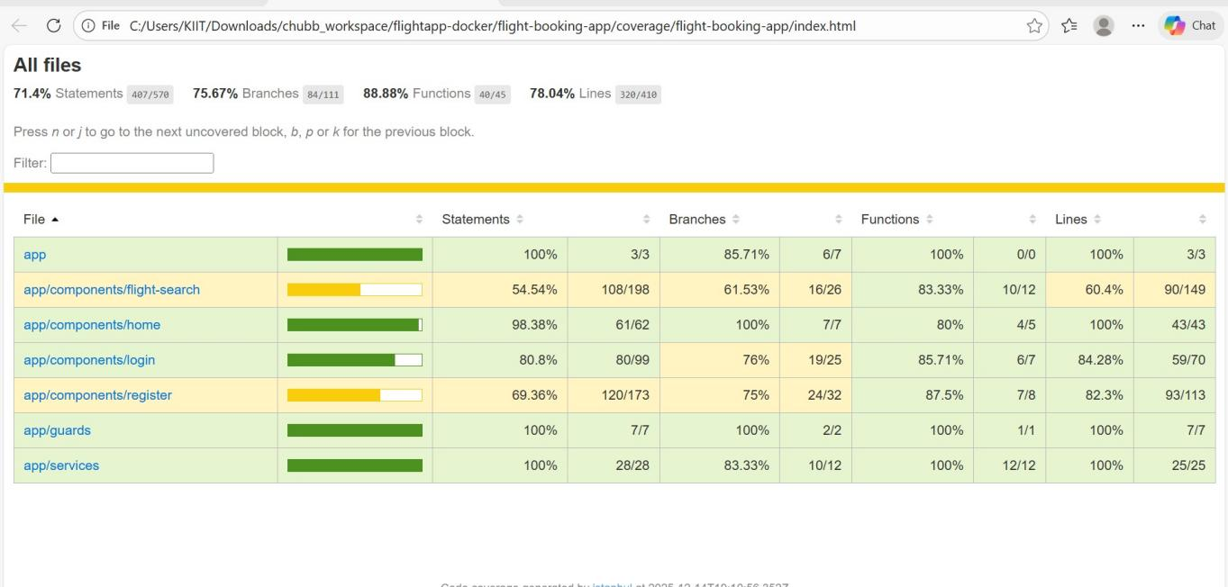

CODE COVERAGE BREAKDOWN

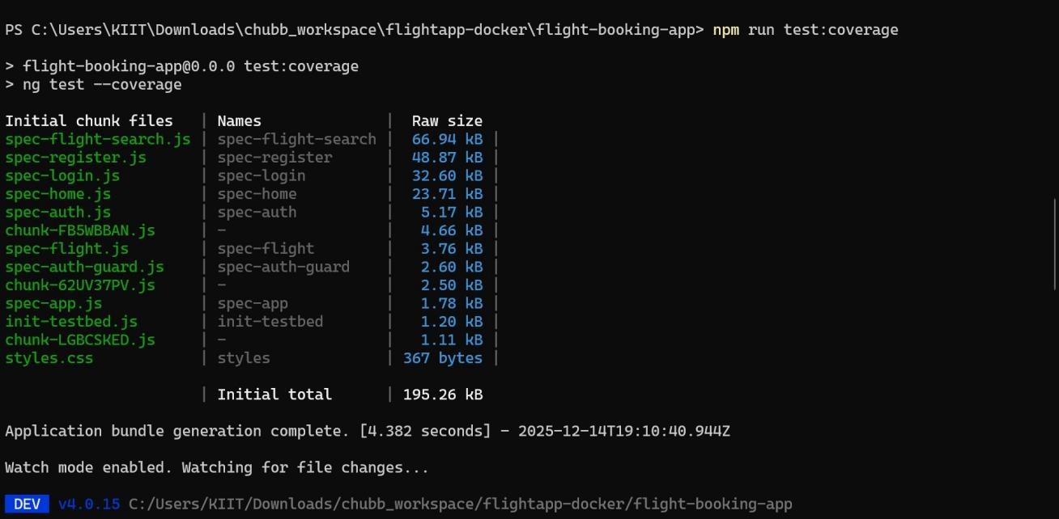

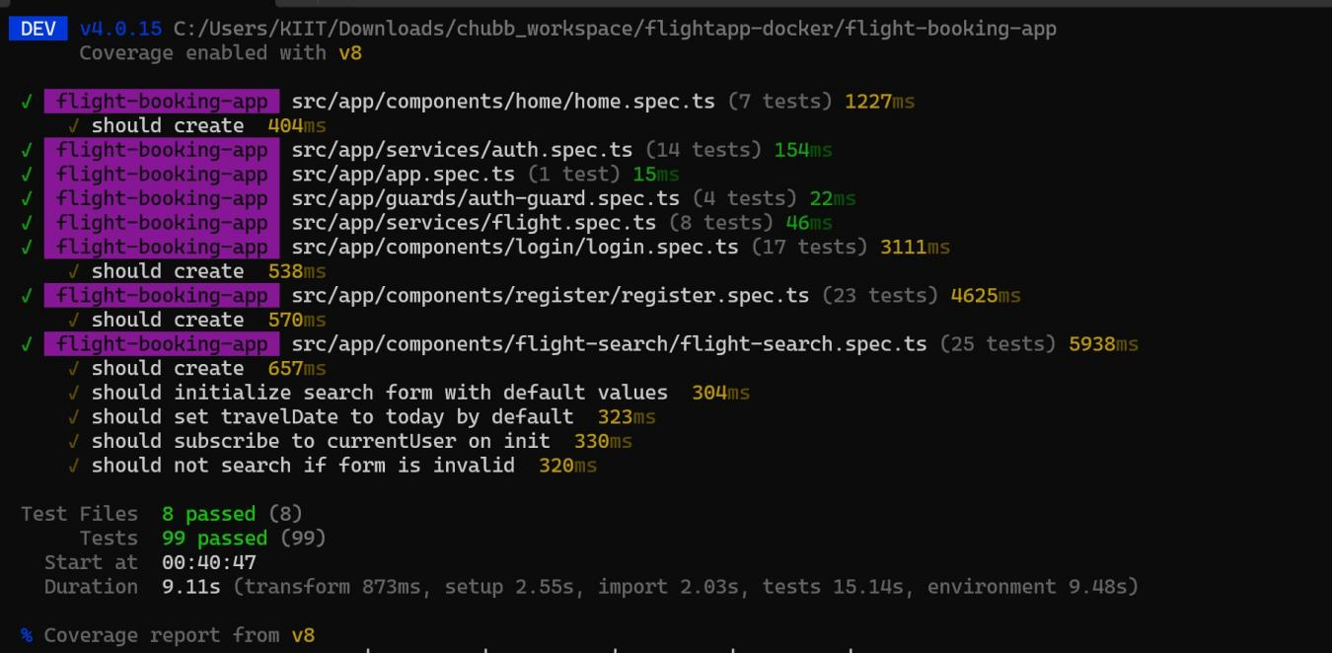

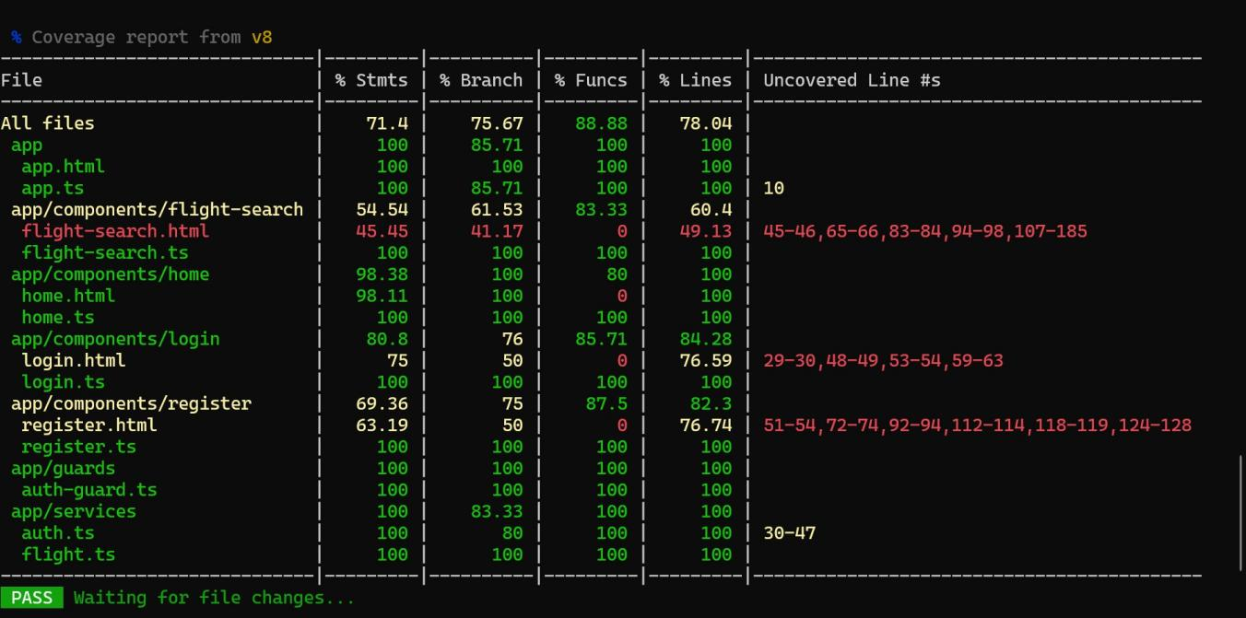

TEST RUN WITH UI

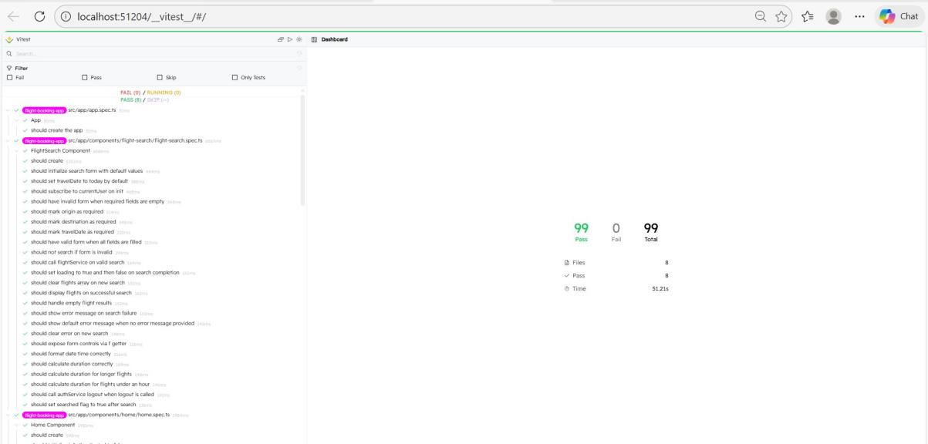

HOME PAGE

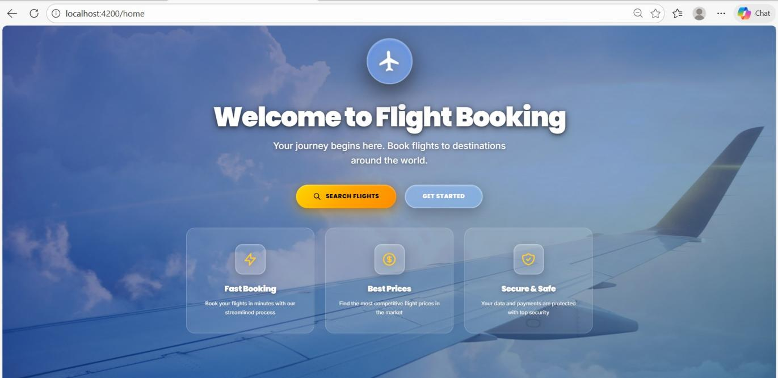

ADMIN LOGIN

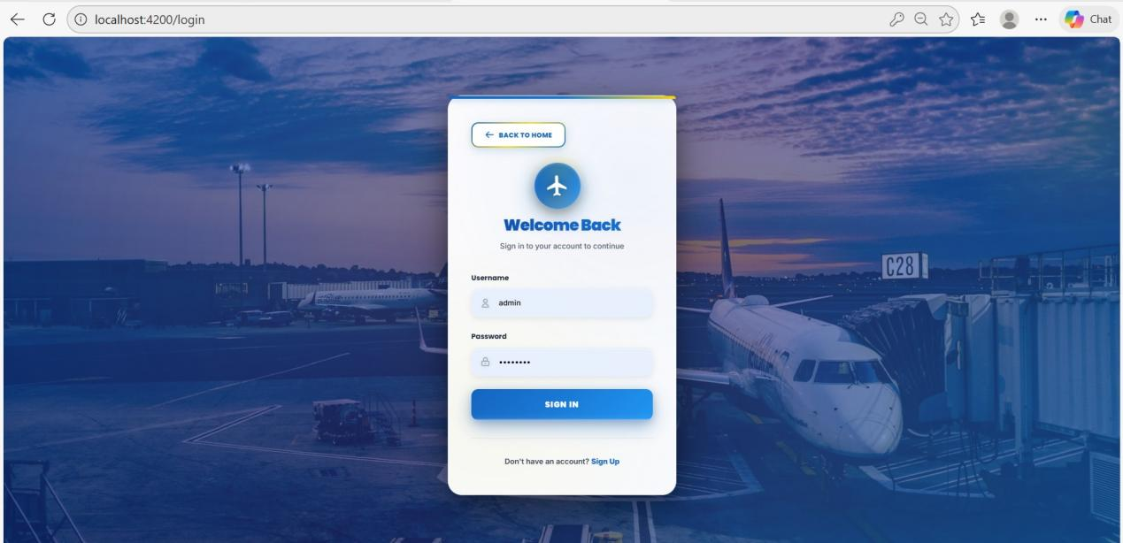

ADMIN DASHBOARD

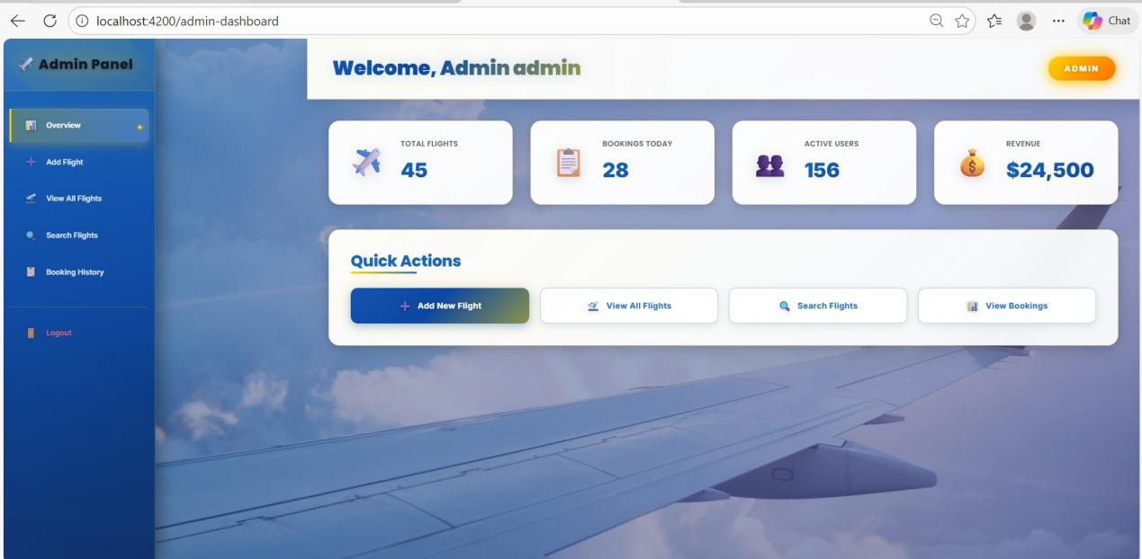

ADD FLIGHT ADMIN FEATURE

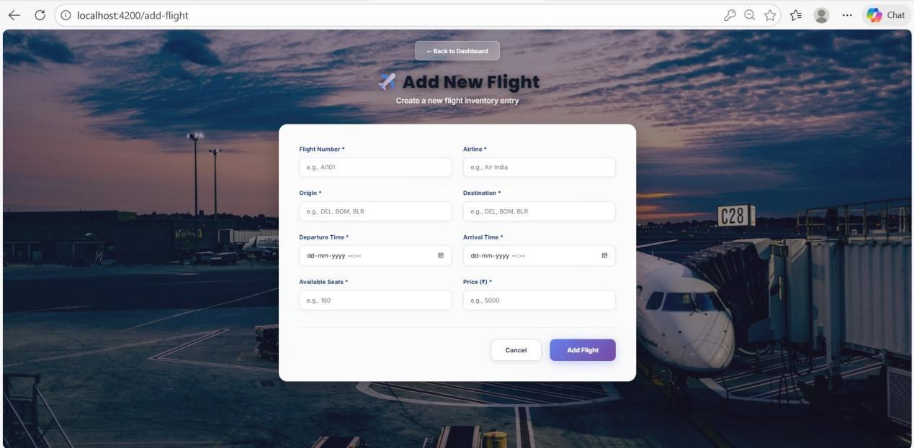

ADD FLIGHT VALIDATION ERROR

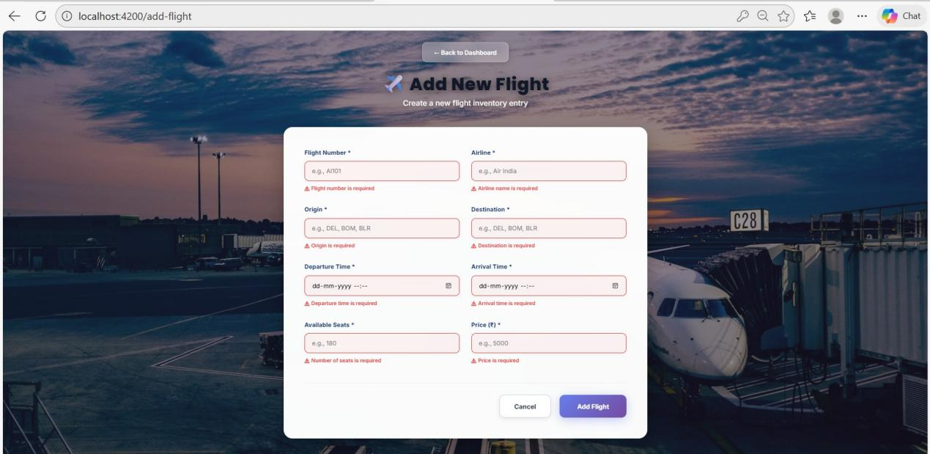

ALL ADDED FLIGHTS

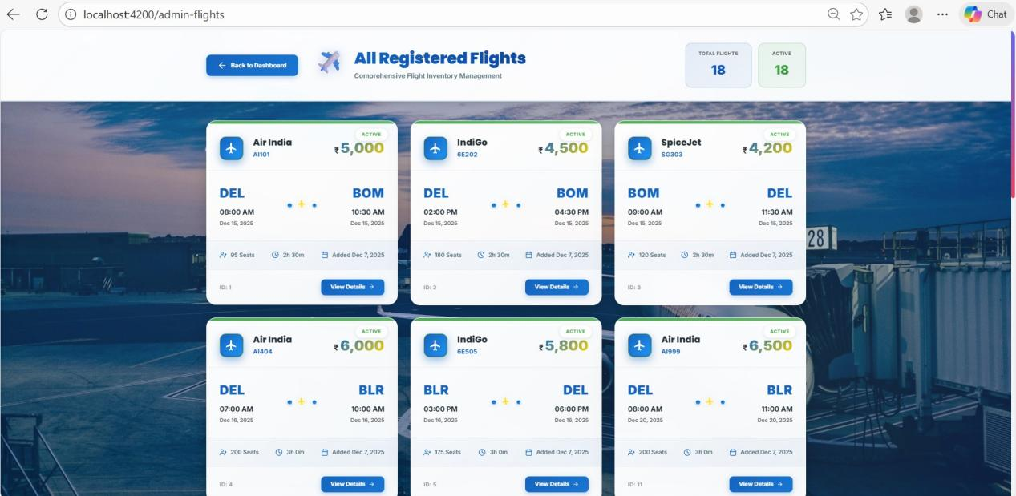

CANCEL BOOKING

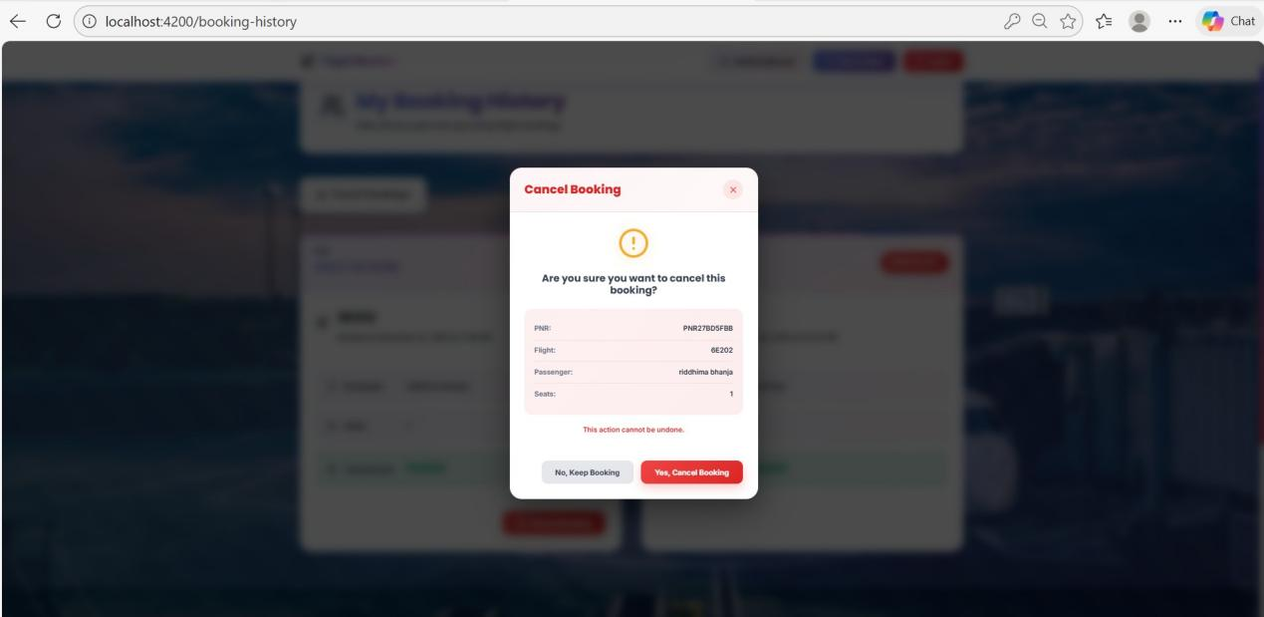

PASSWORD EXPIRATION ALERT

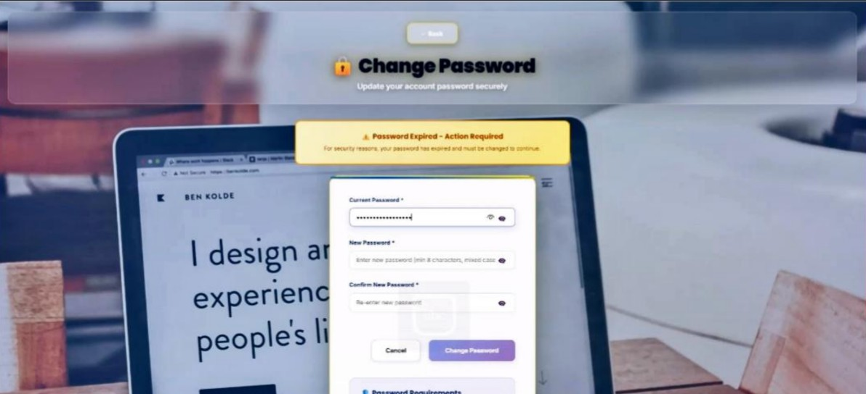

PASSWORD EXPIRY VALIDATION

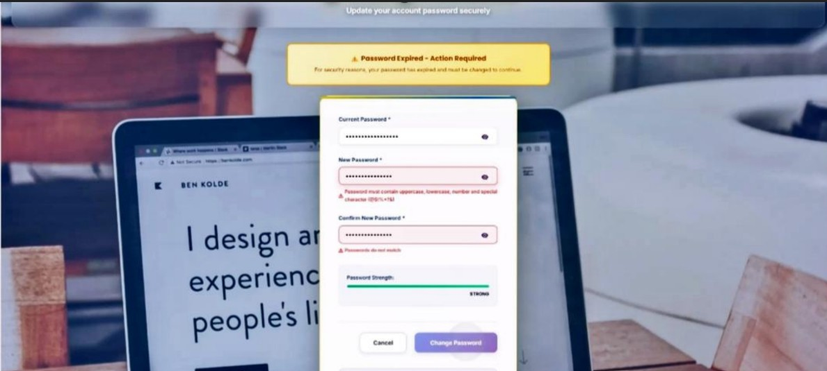

PASSWORD EXPIRY VALIDATION-2

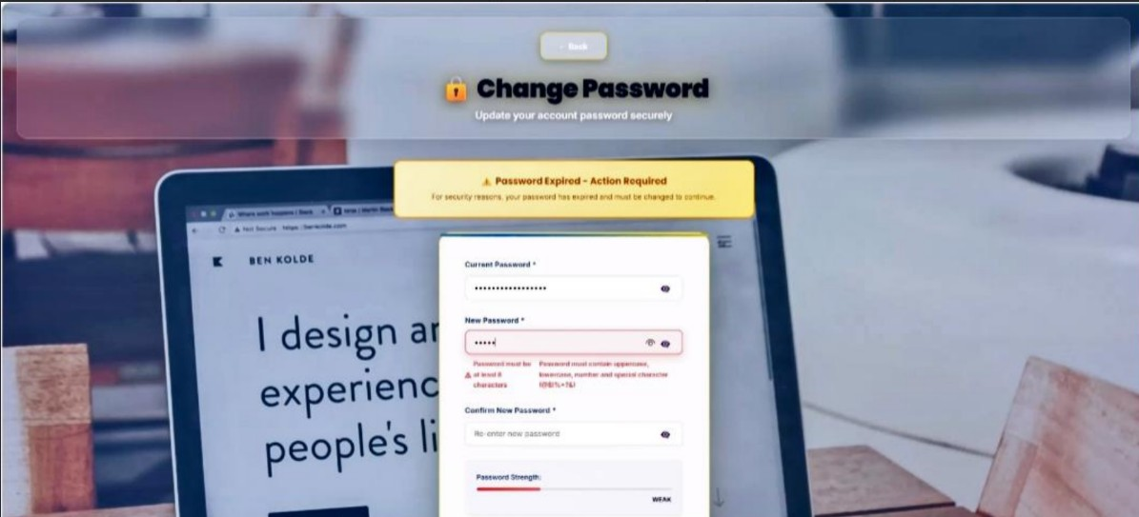

CHANGE PASSWORD SUCCESS

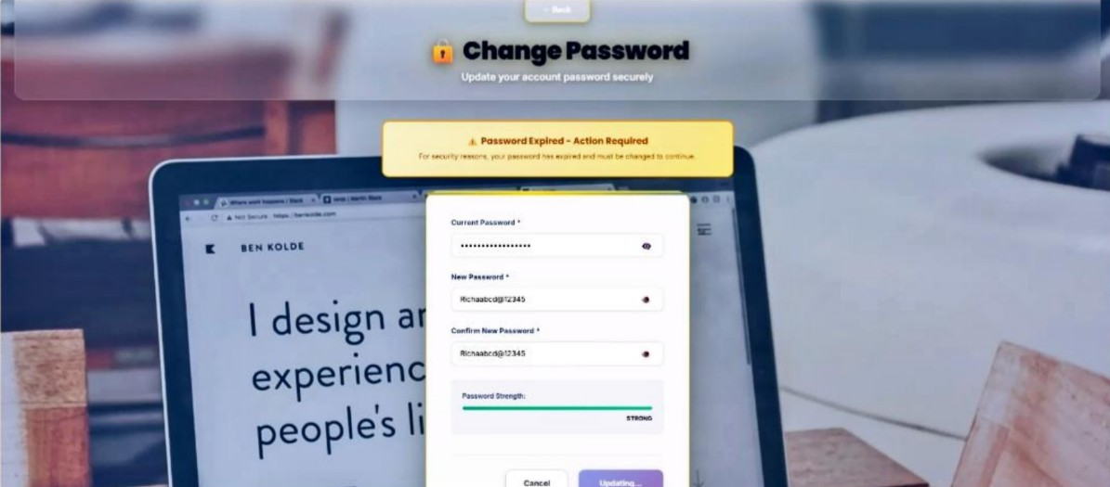

USER DASHBOARD

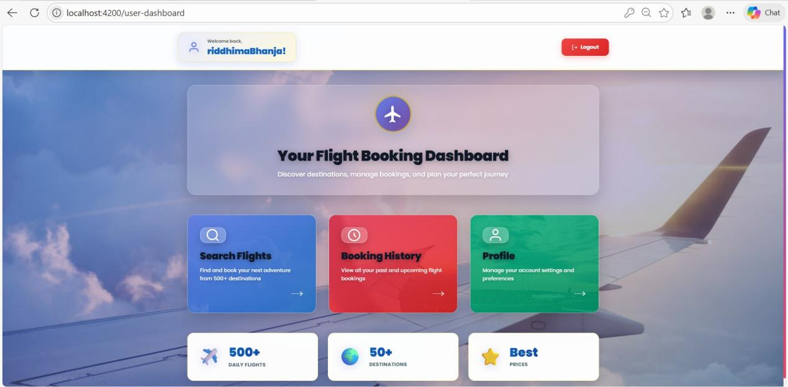

SEARCH FLIGHT

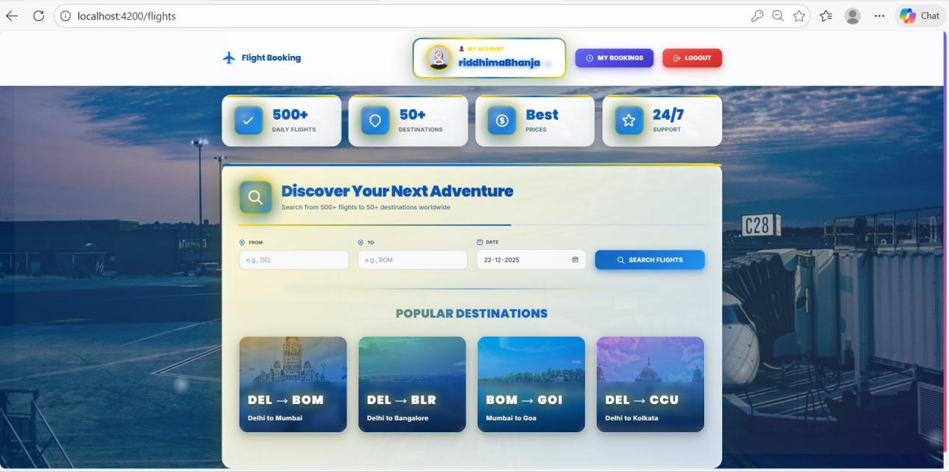

BOOK FLIGHT

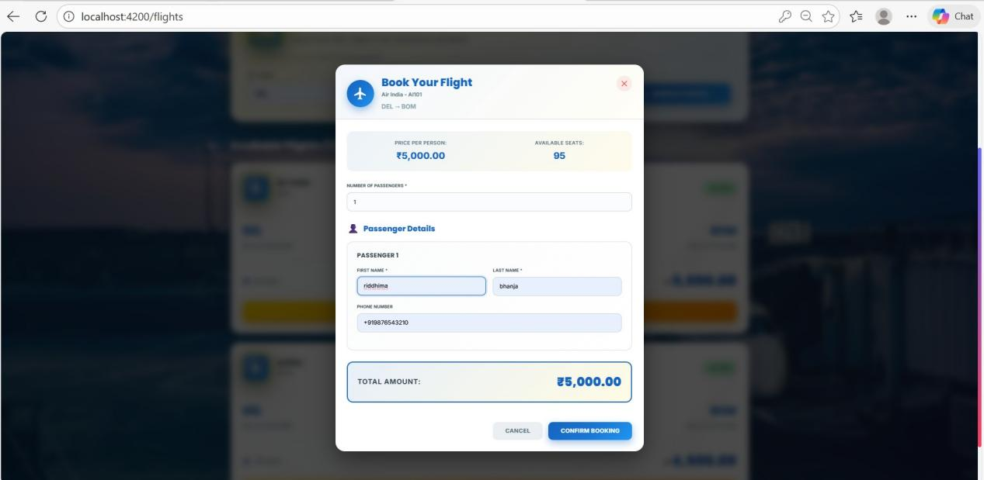

BOOK FLIGHT VALIDATION ERROR

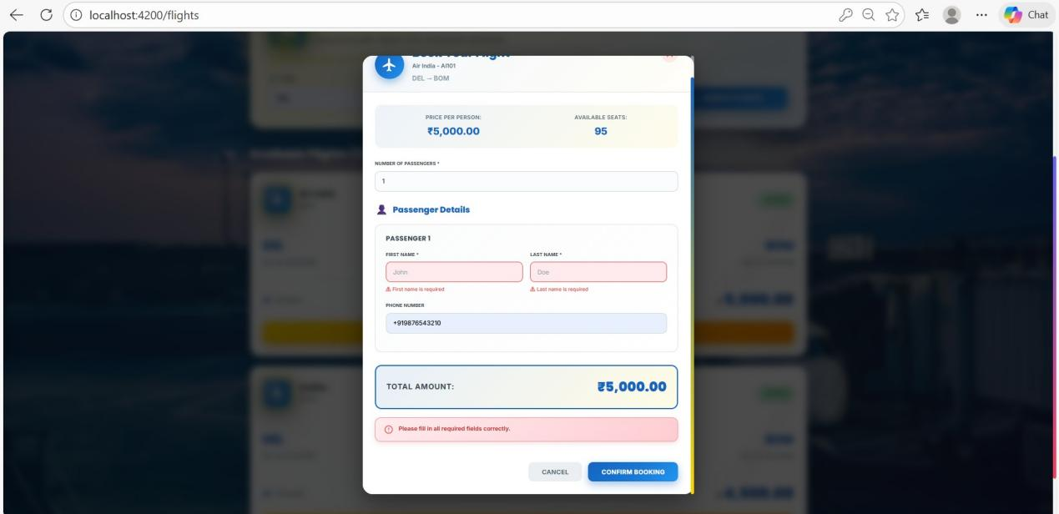

BOOKING HISTORY

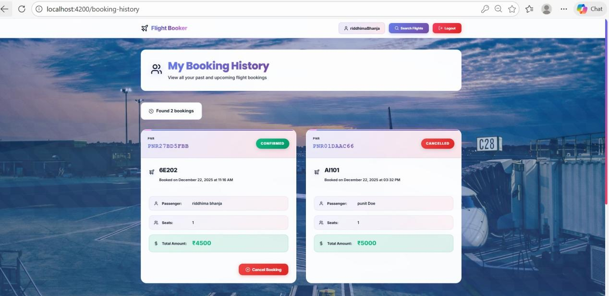

CHANGE PASSWORD FOR USER

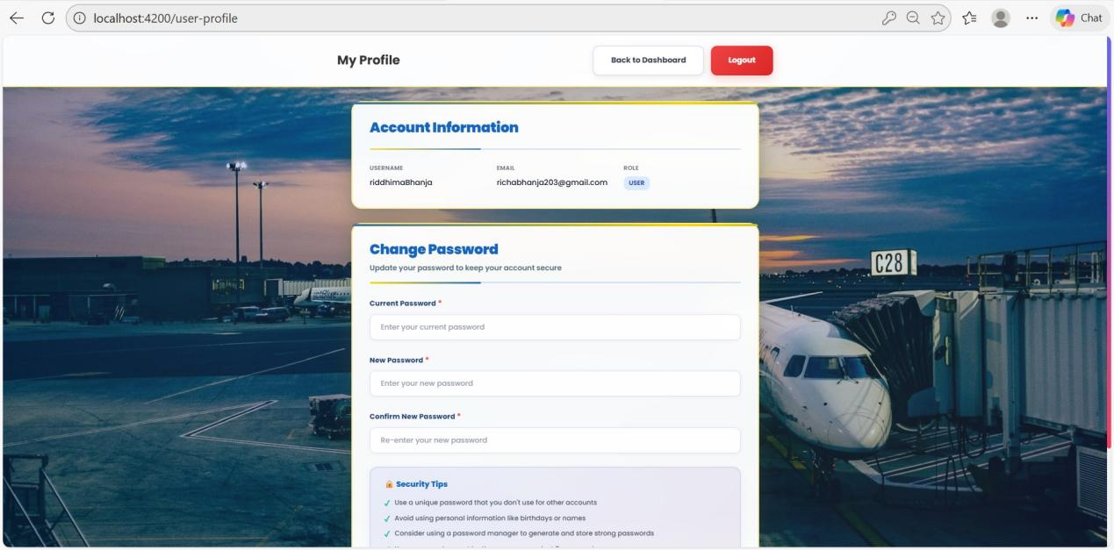

CHANGE PASSWORD VALIDATION ERROR

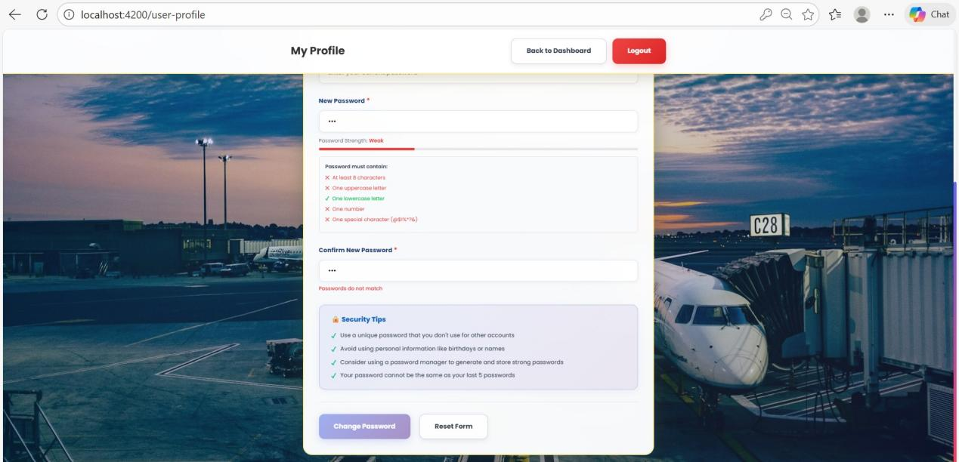

CLEAN REGISTER PAGE

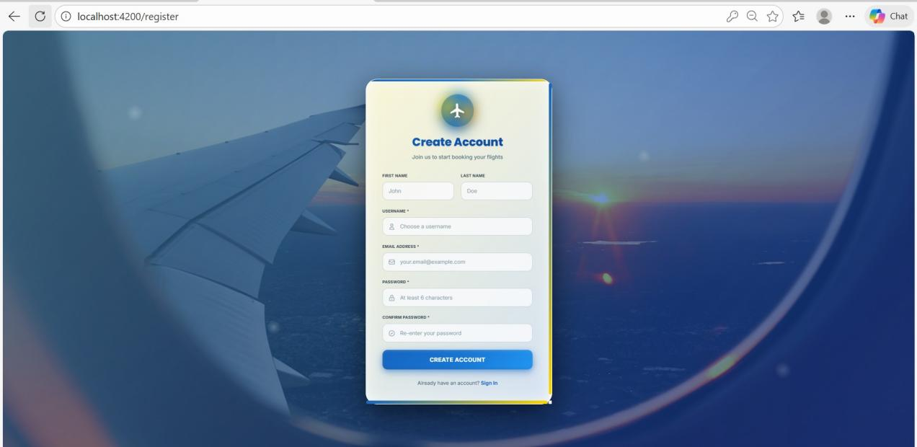

REGISTER PAGE(ACCOUNT CREATION)

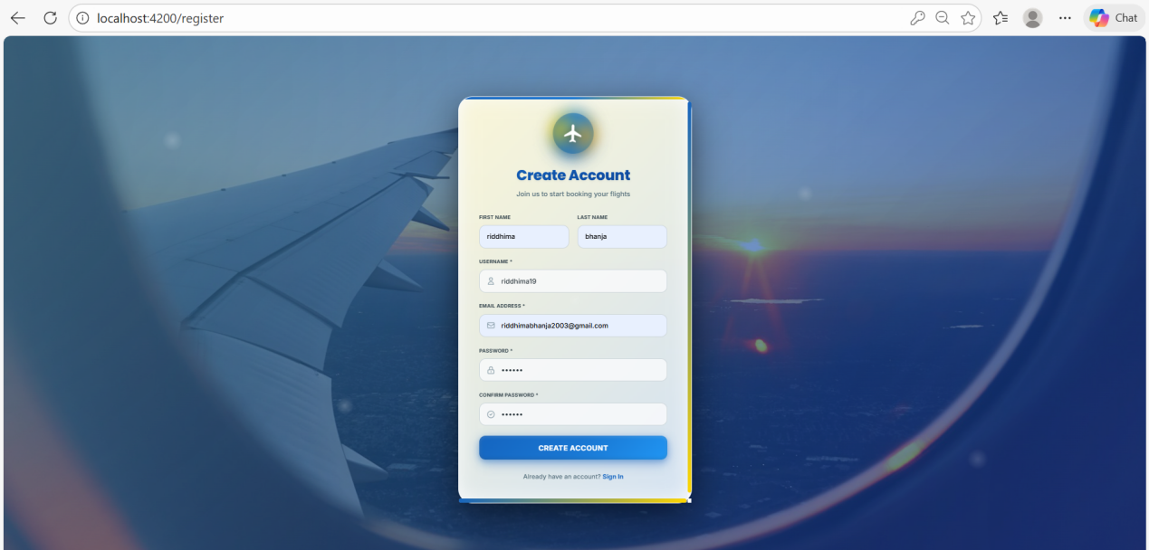

LOGIN PAGE

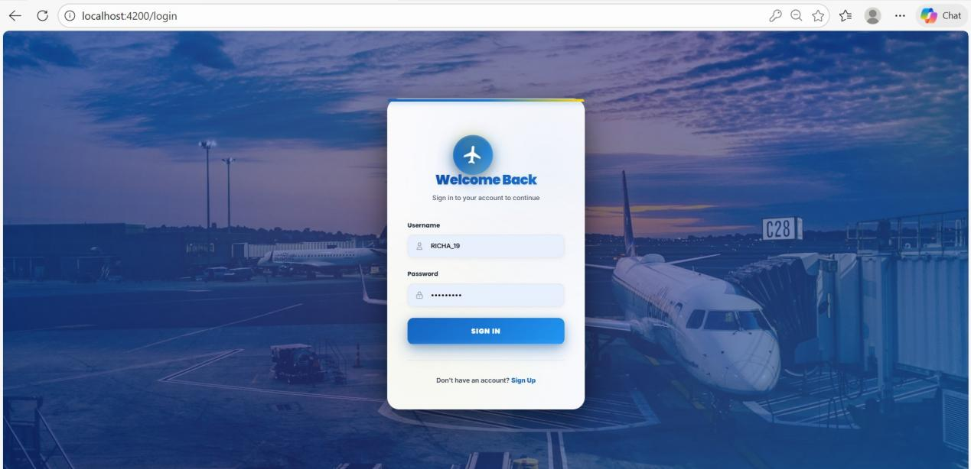

CLEAN LOGIN PAGE

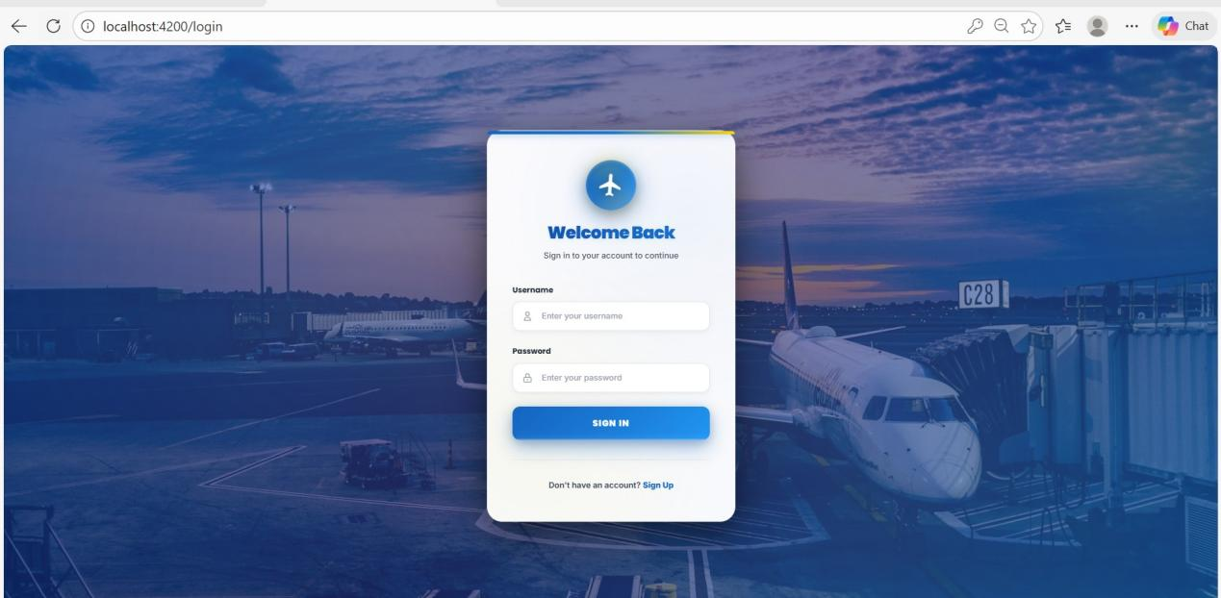

SEARCH FLIGHTS

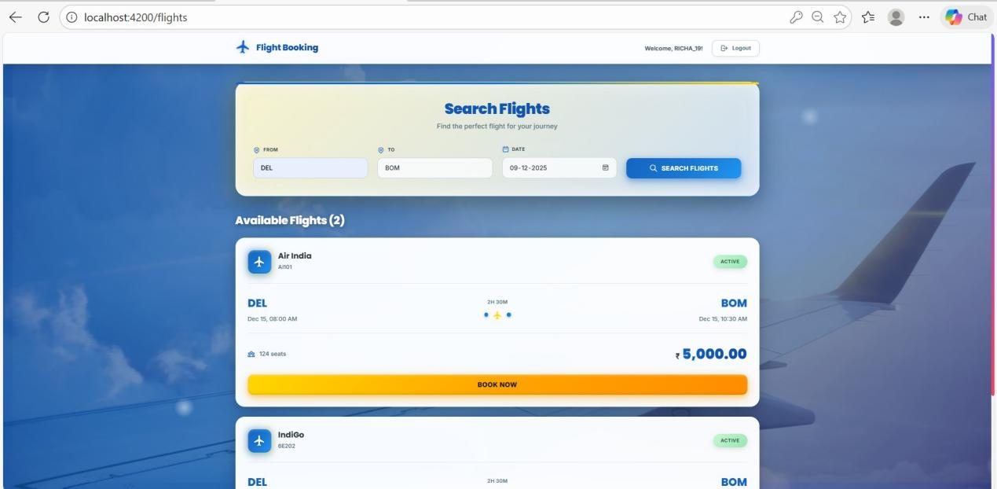

CLEAN SEARCH FLIGHTS

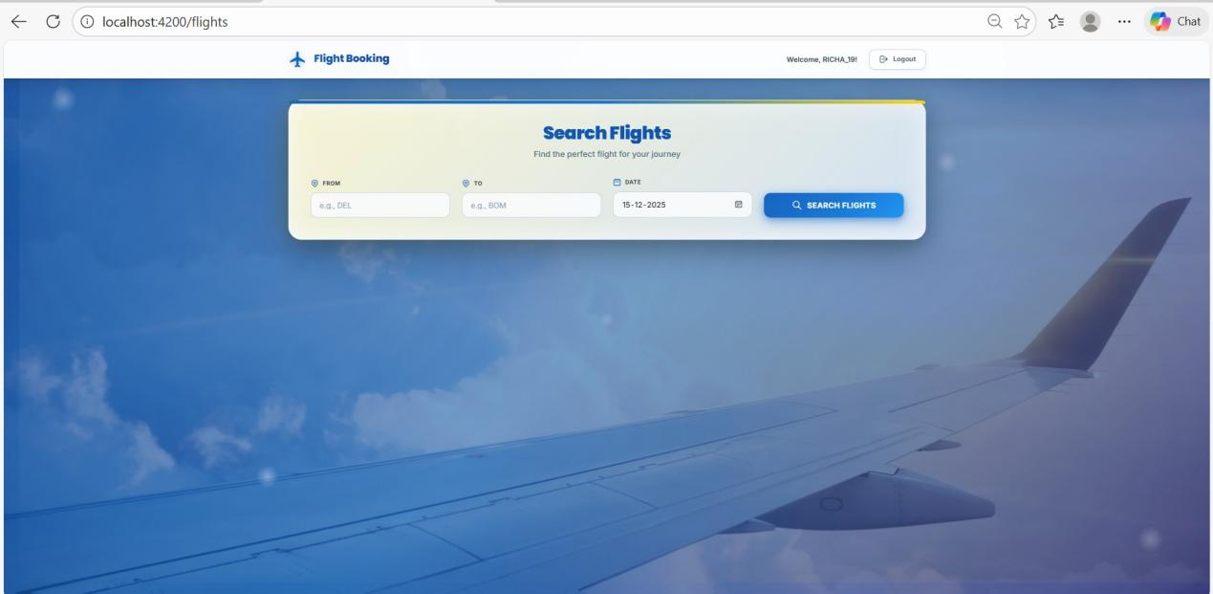

VALIDATION ERRORS

SEARCH FLIGHT VALIDATION ERROR

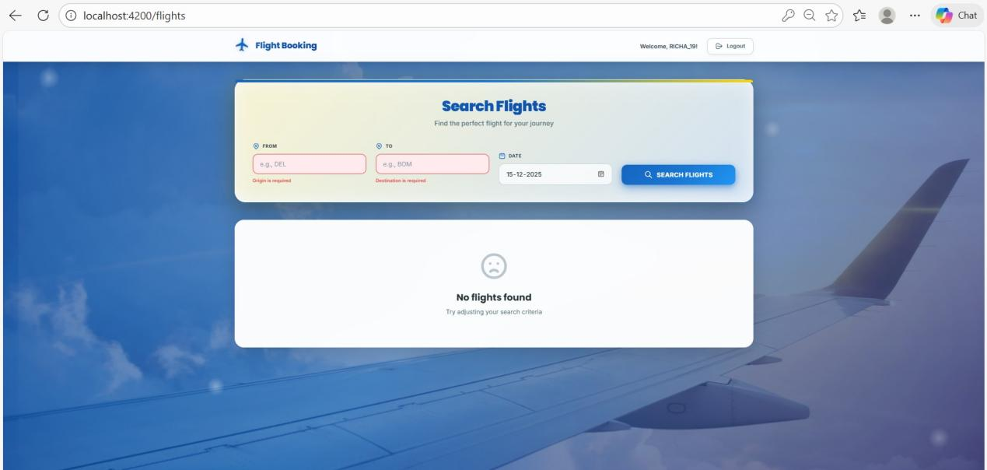

LOGIN VALIDATION ERROR

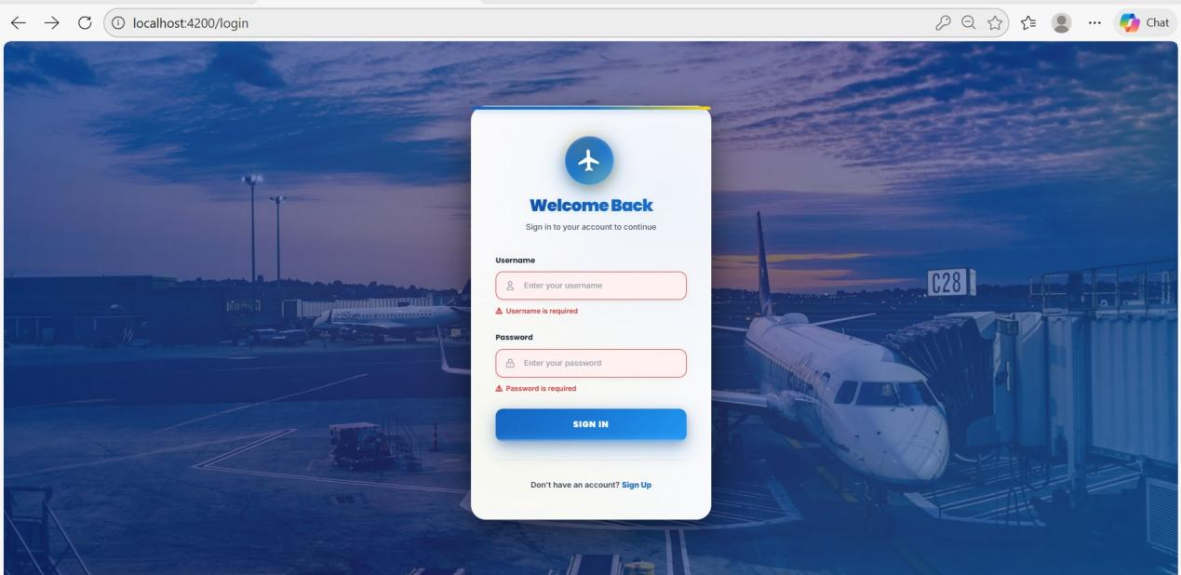

EMAIL VALIDATION ERROR

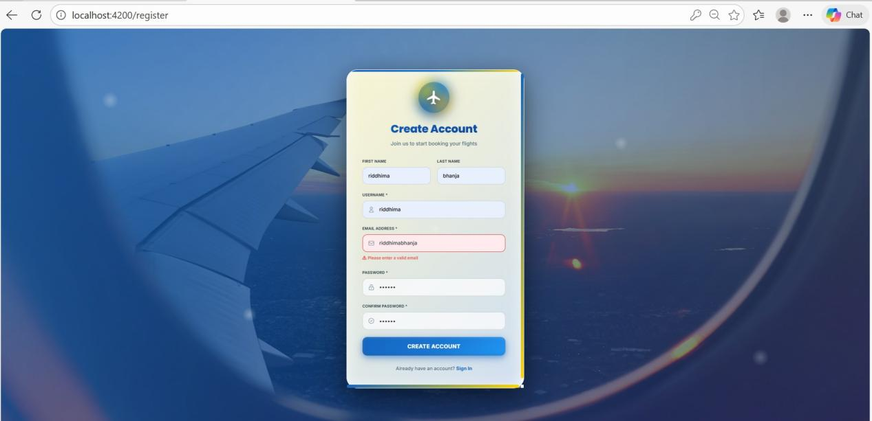

REGISTRATION VALIDATION ERROR

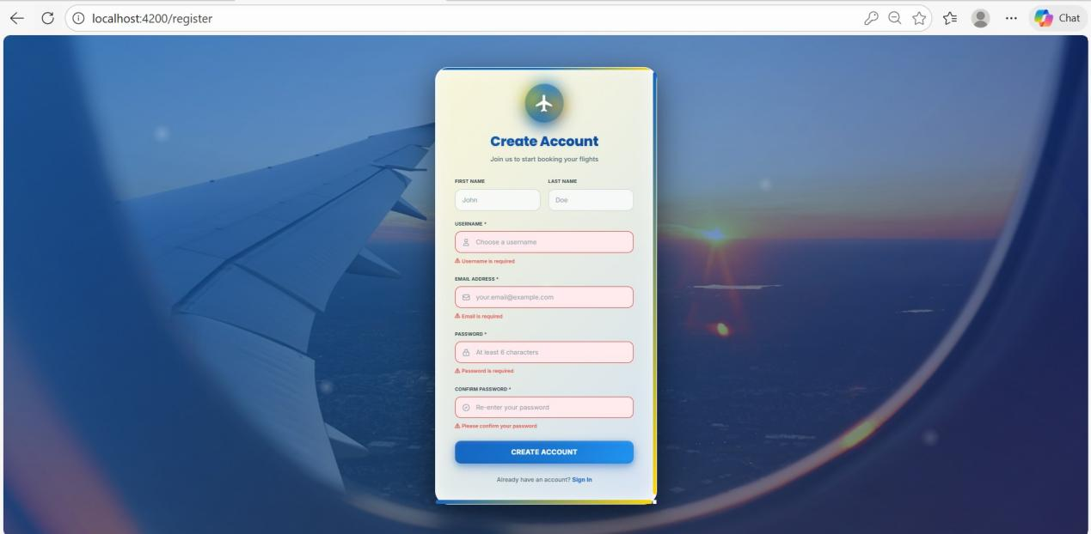

PASSWORD MISMATCH ERROR

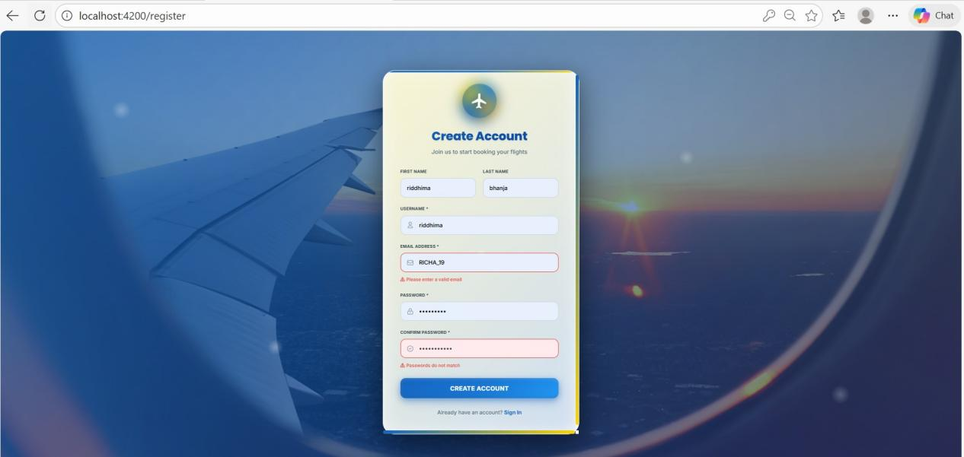

MONGODB DATA

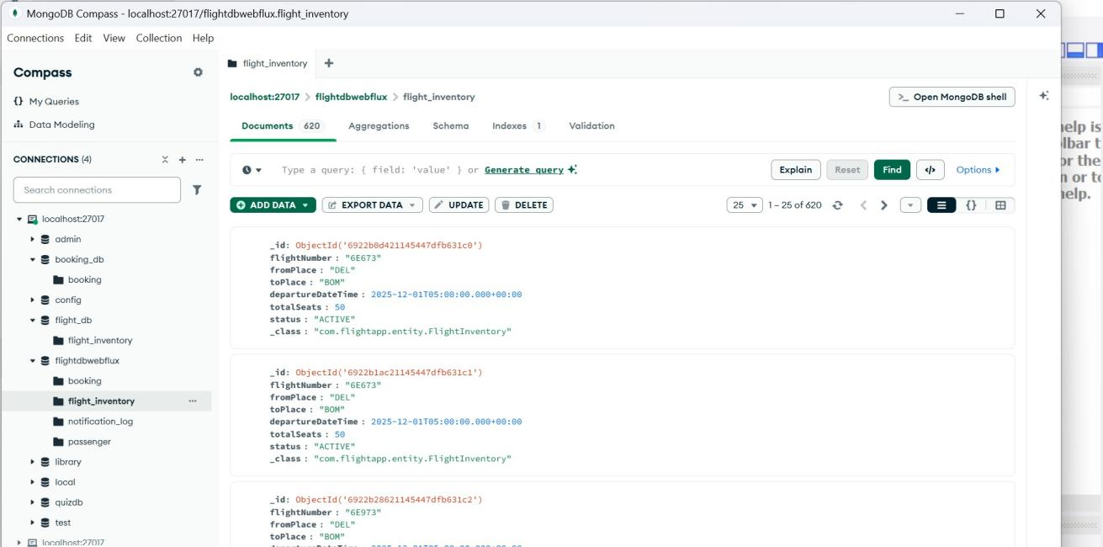

MYSQL WORKBENCH

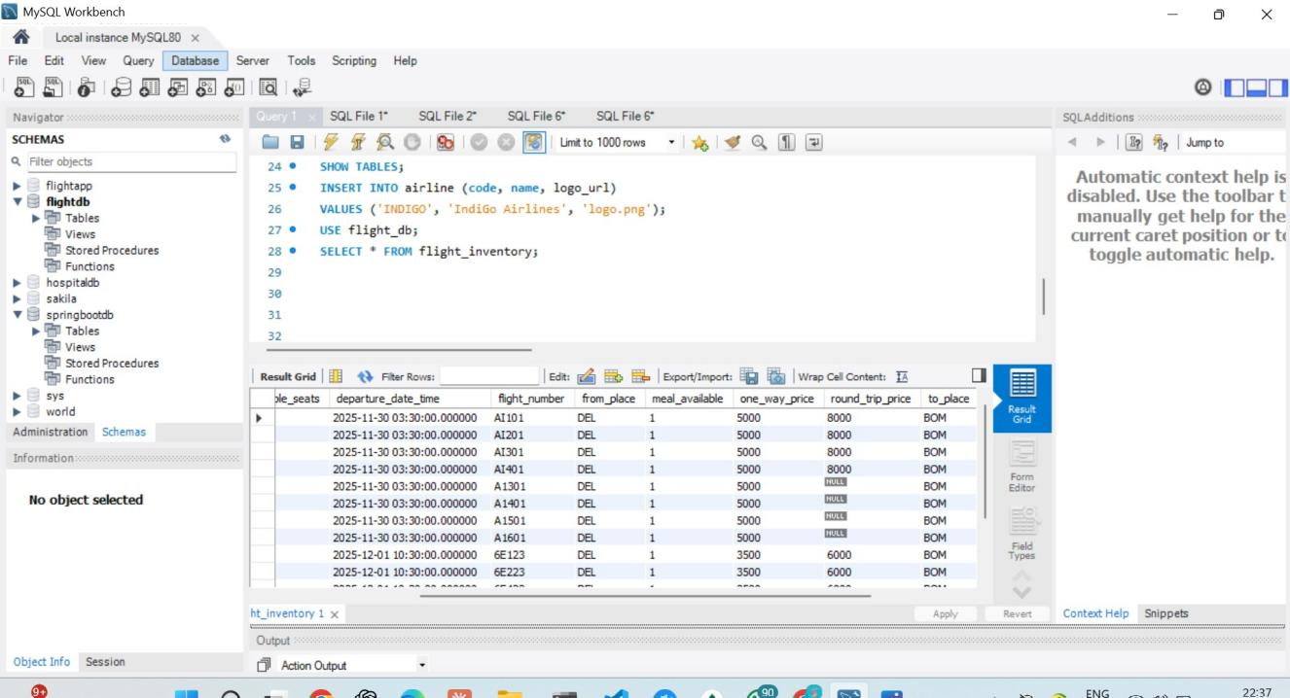

JACOCO REPORTS

FLIGHT SERVICE:

98% COVERAGE

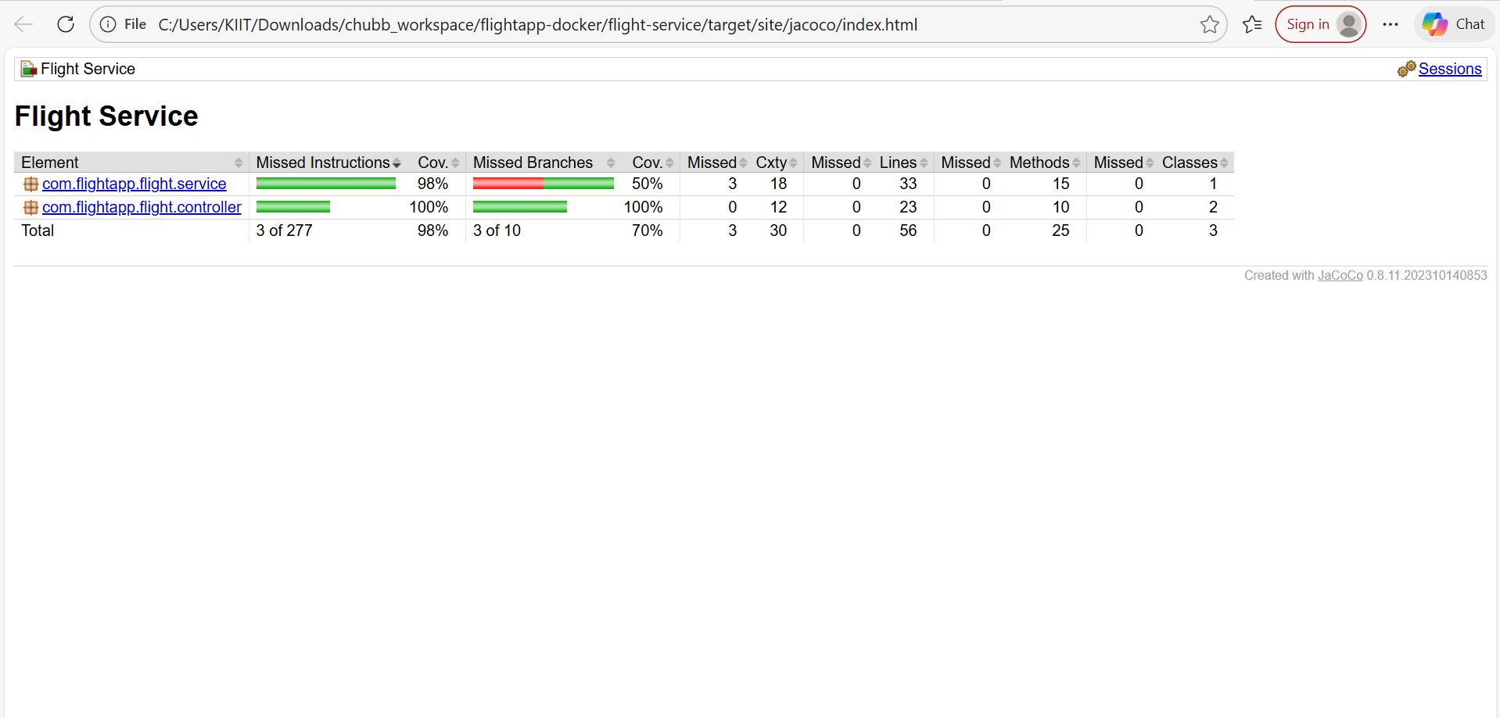

BOOKING SERVICE

**94% coverage**

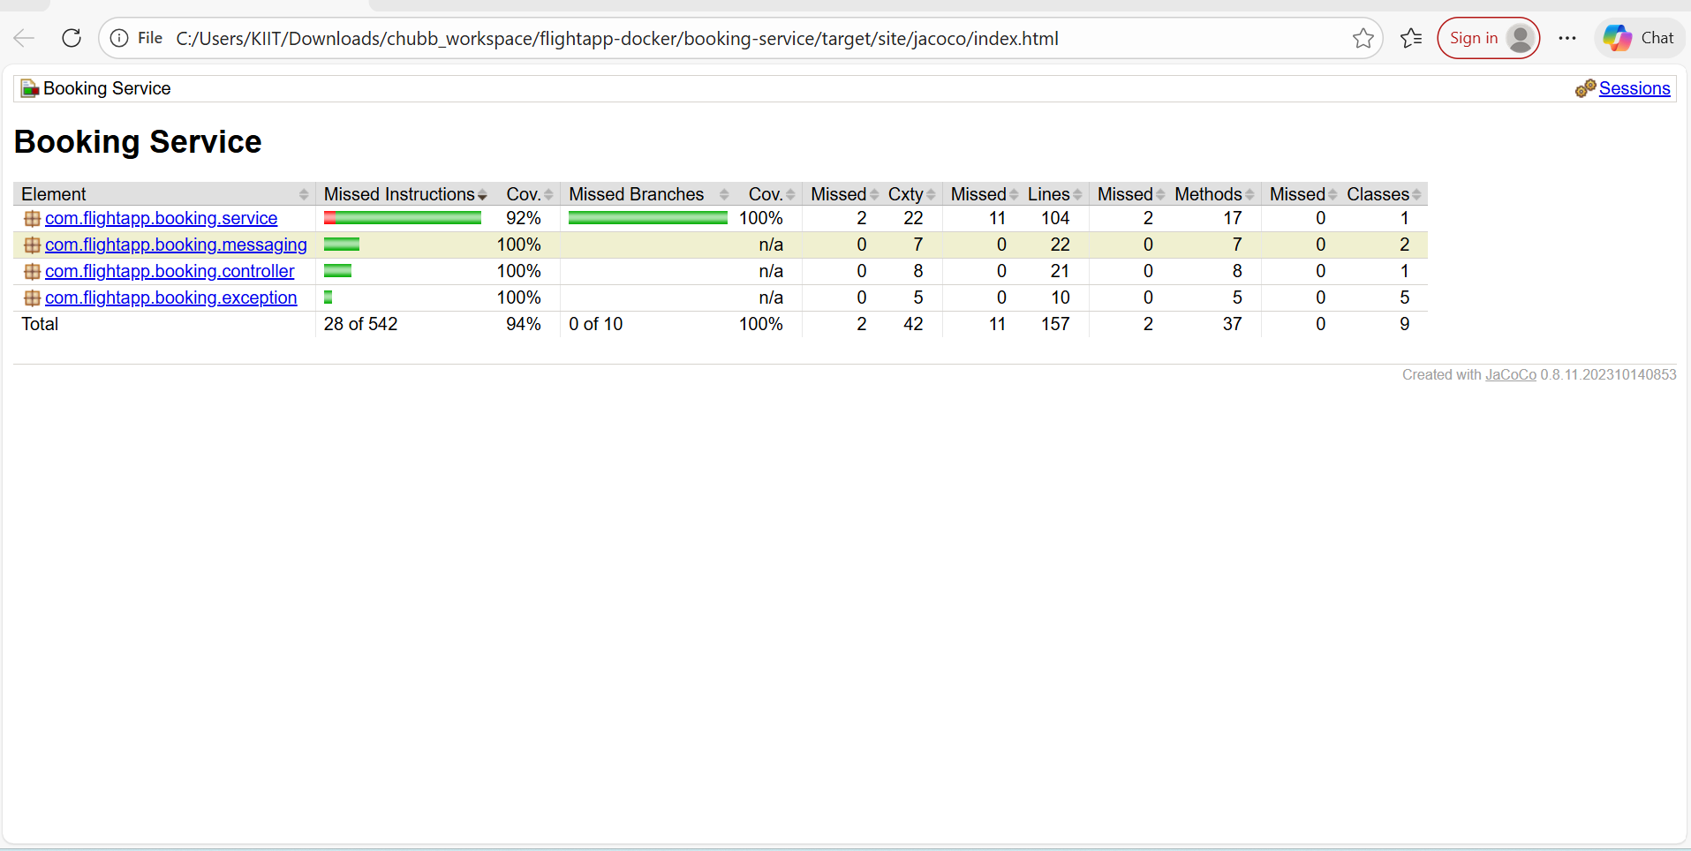

**ER DIAGRAM**

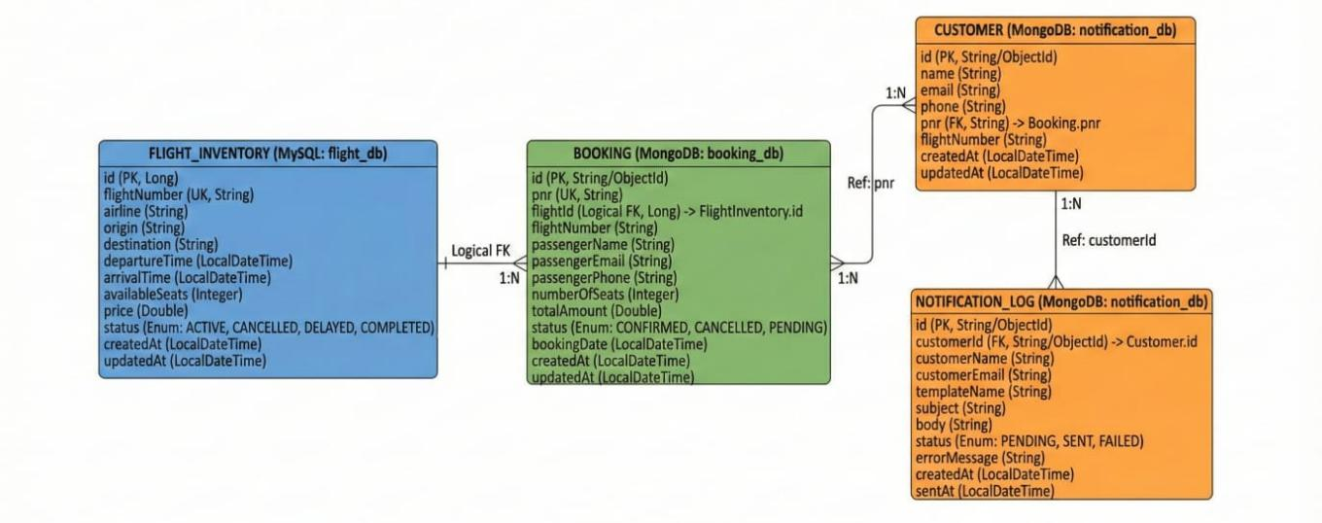

1. SonarQUBE Code Coverage

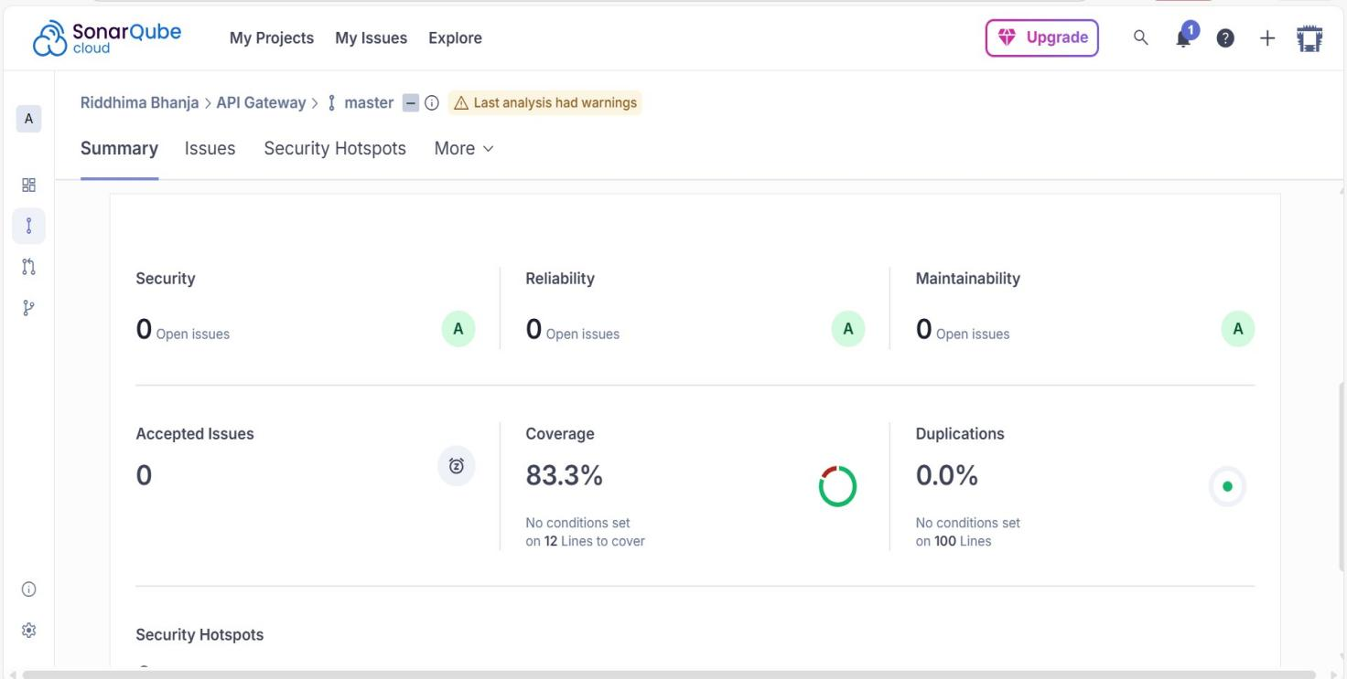

1. SonarQube Issues

**Before fixing:**

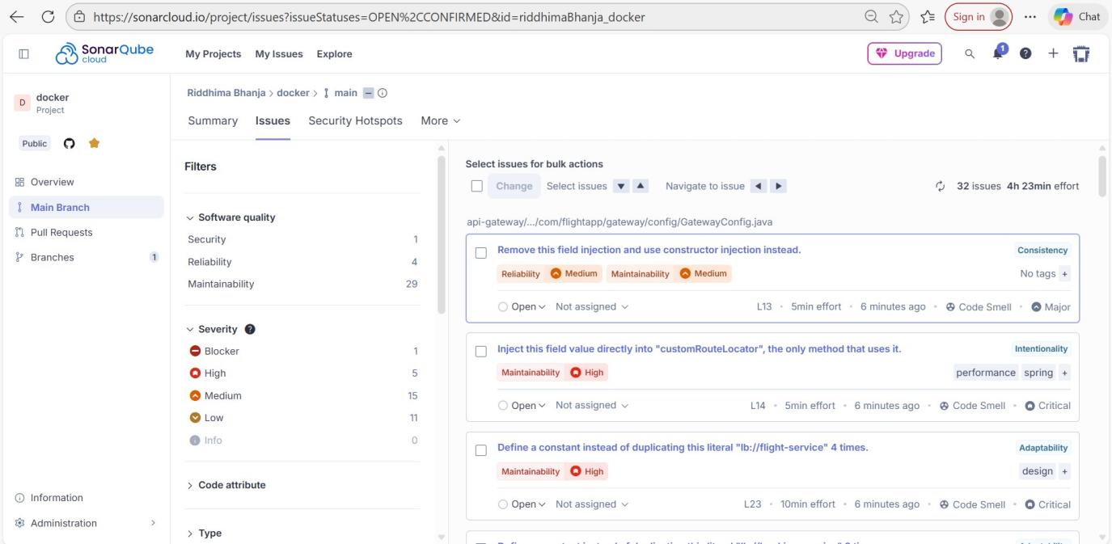

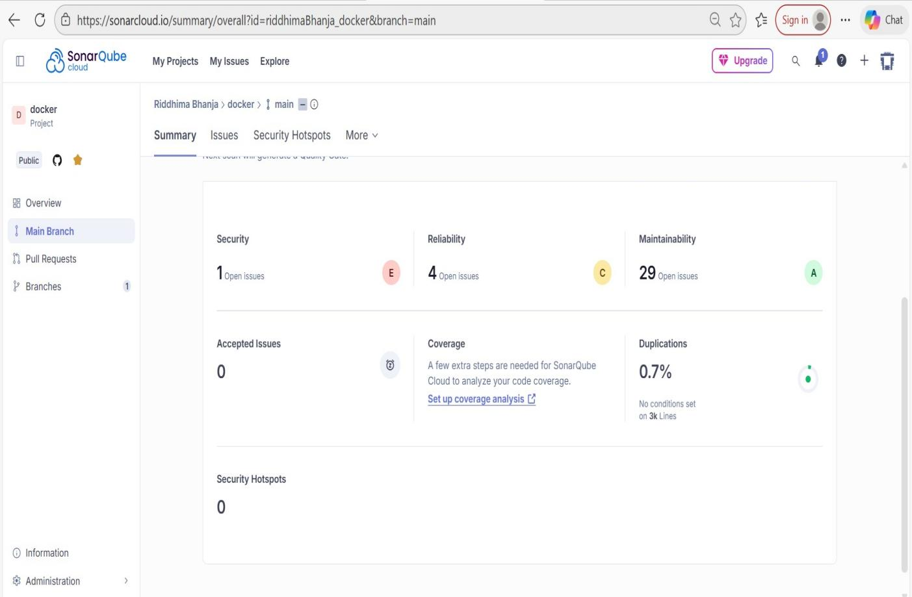

**After fixing:**

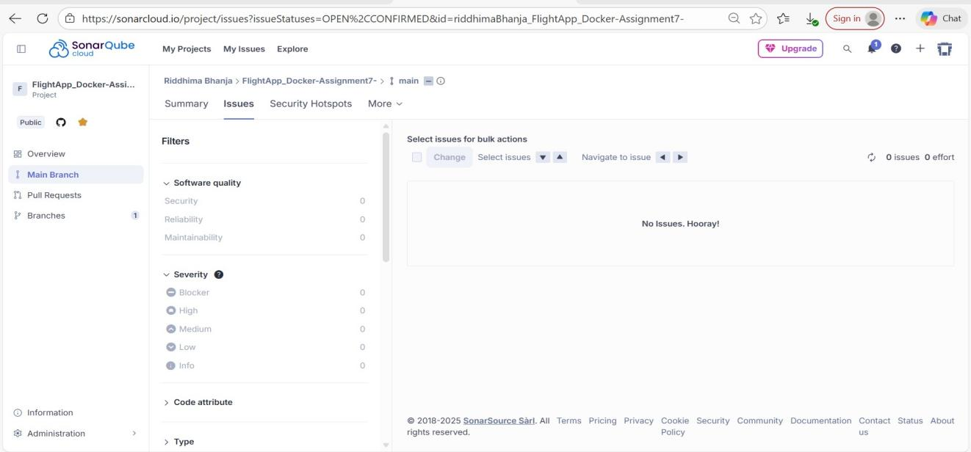

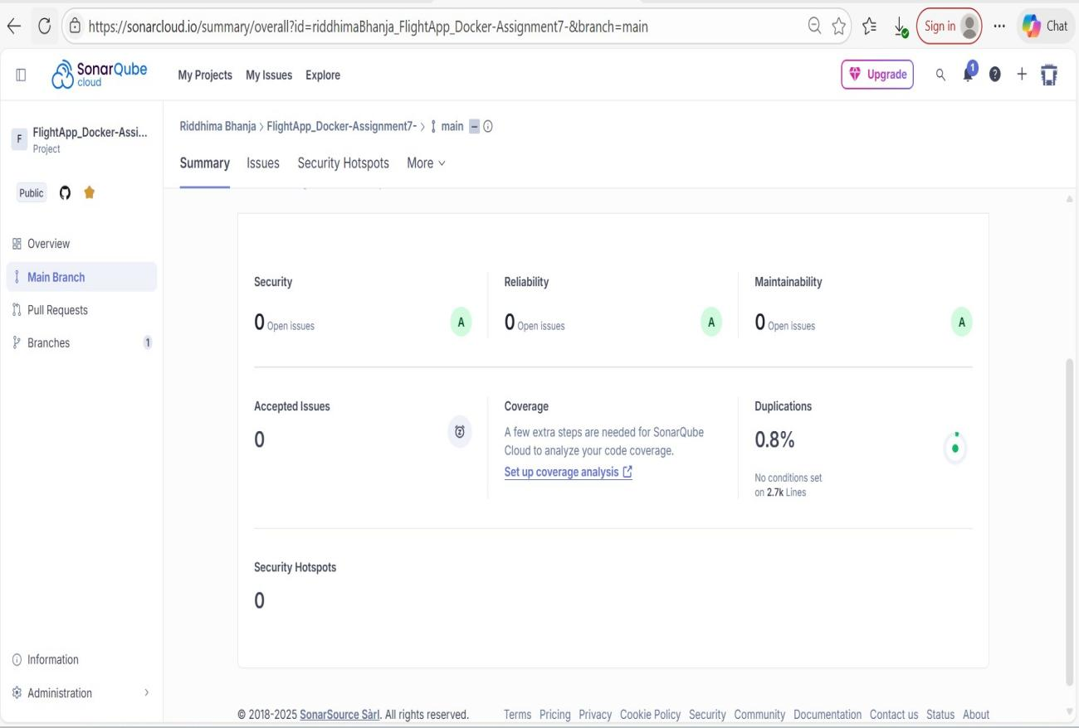

1. System Architecture

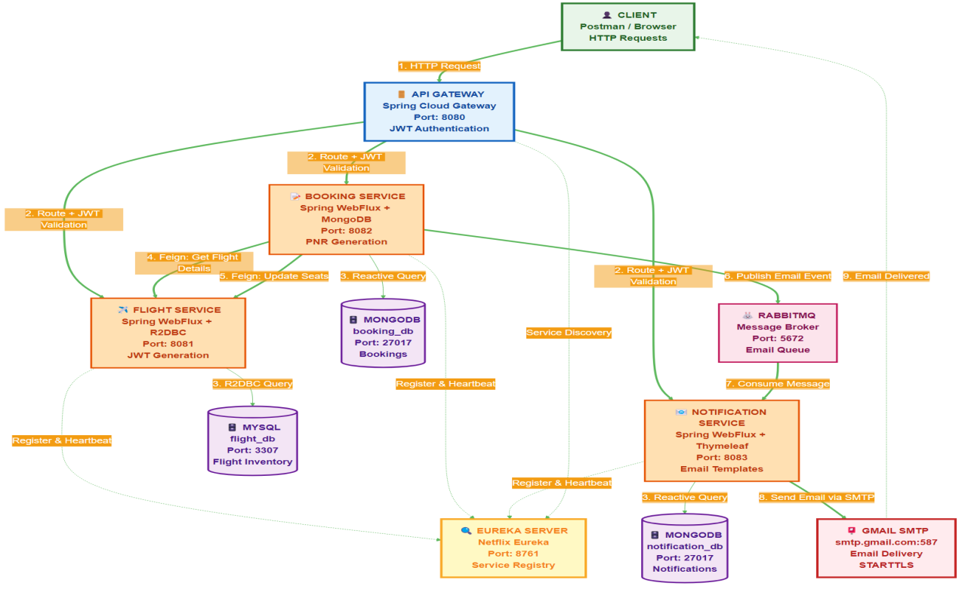

1. Jmeter

* Apache Jmeter Dashboard

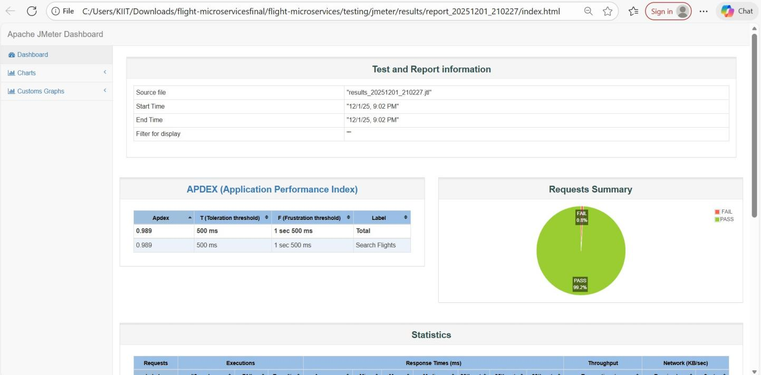

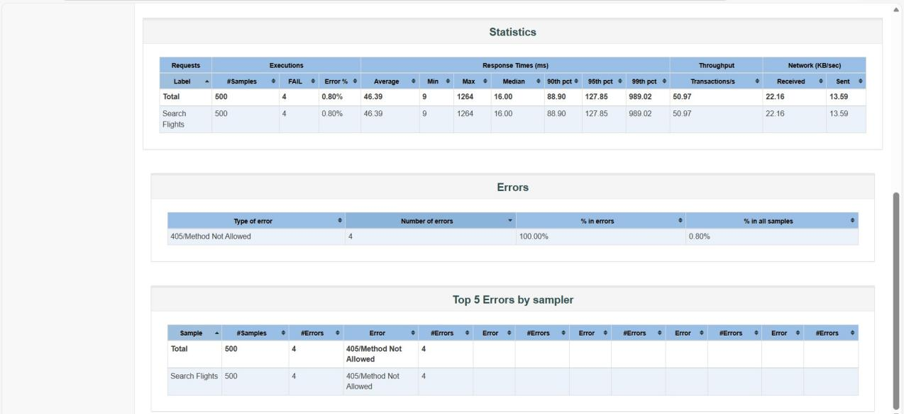

LOGS SCREENSHOTS

DASHBOARD

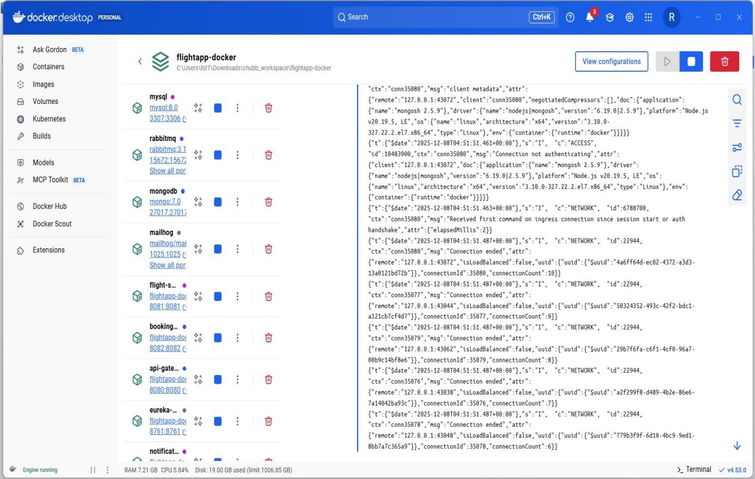

EUREKA SERVER LOGS

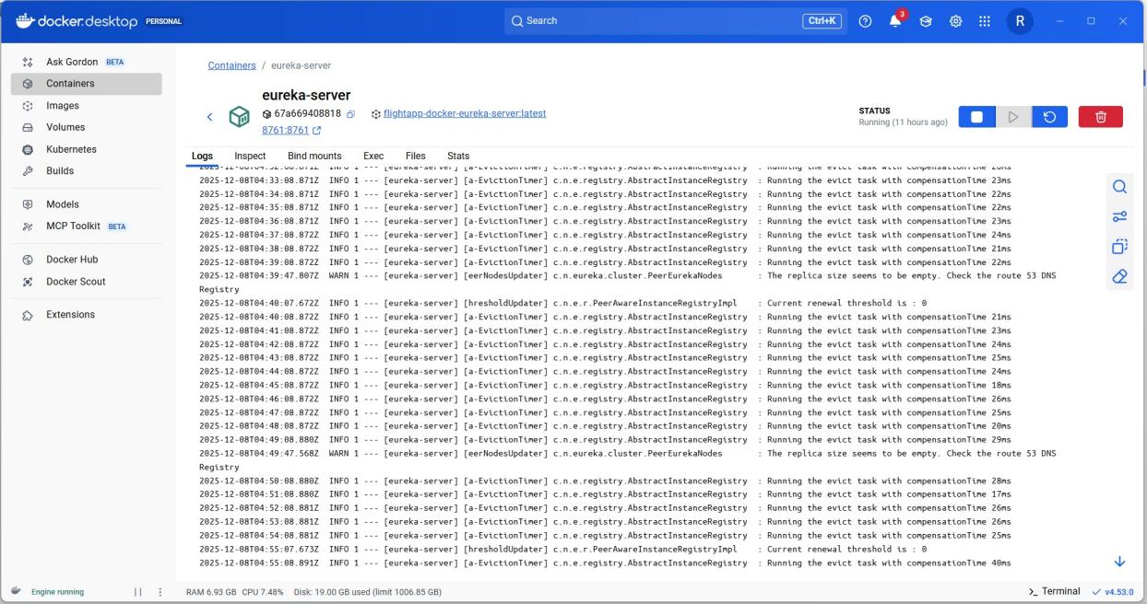

API GATEWAY

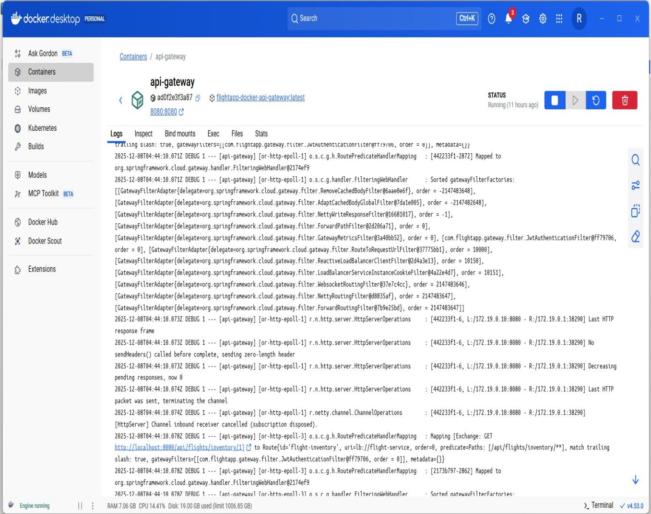

BOOKING SERVICE LOGS

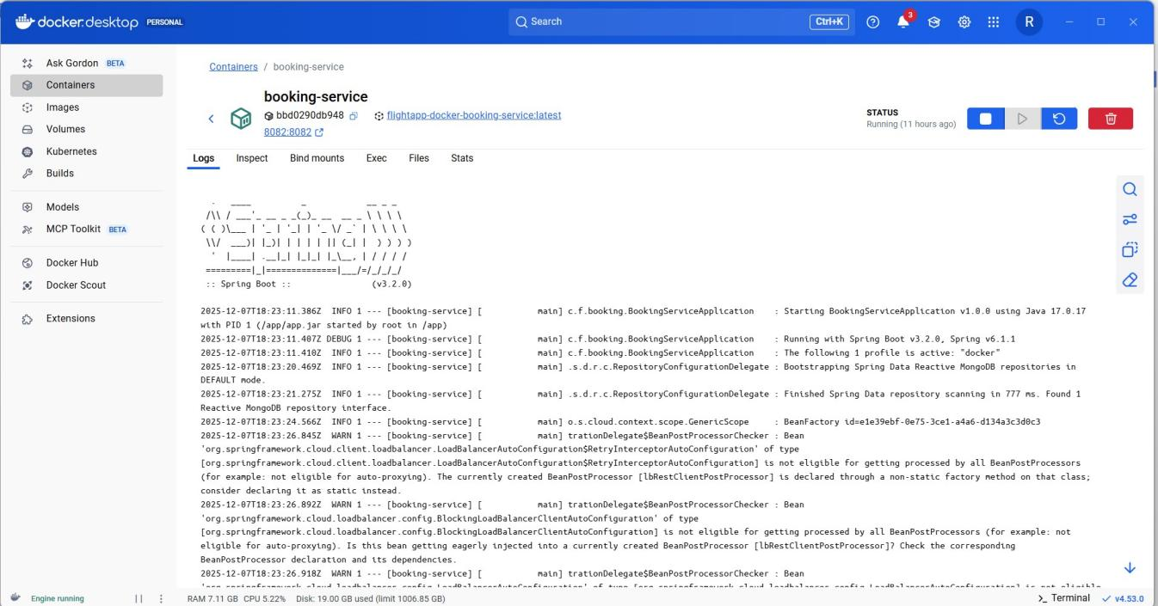

FLIGHT SERVICE LOGS

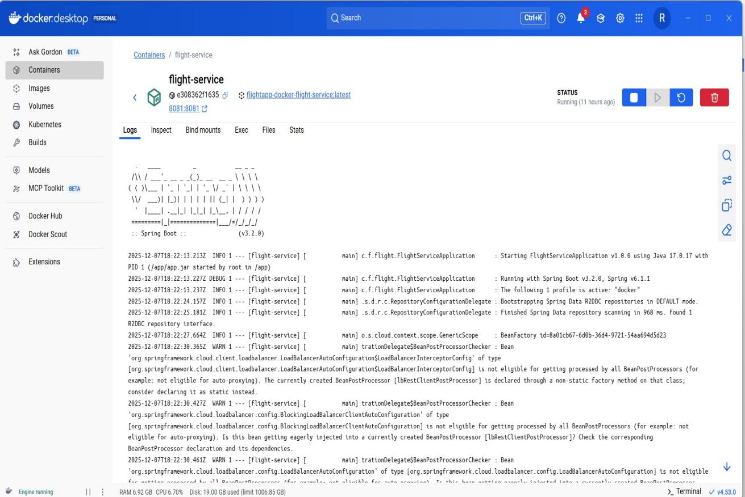

NOTIFICATION SERVICE LOGS

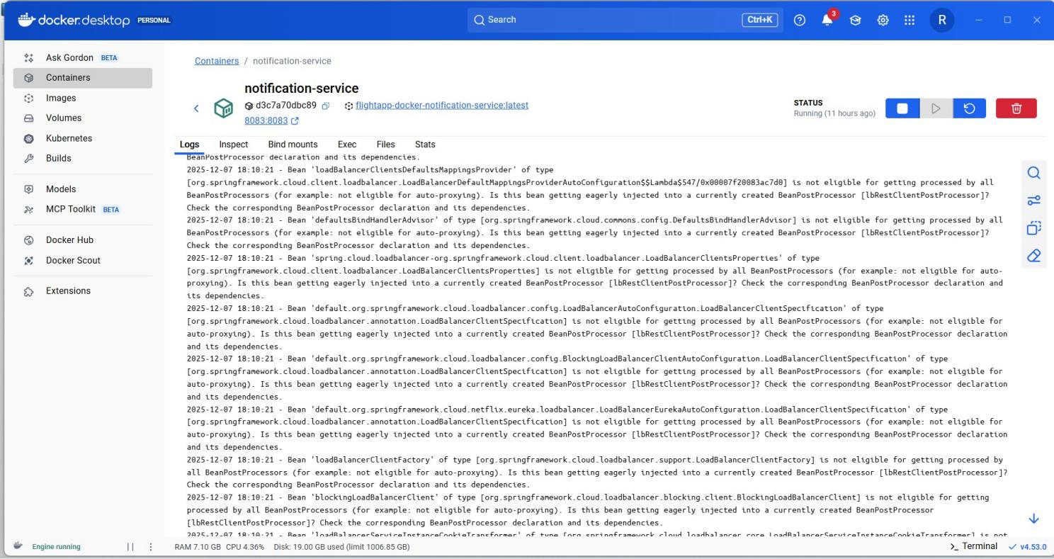

RabbitMQ logs

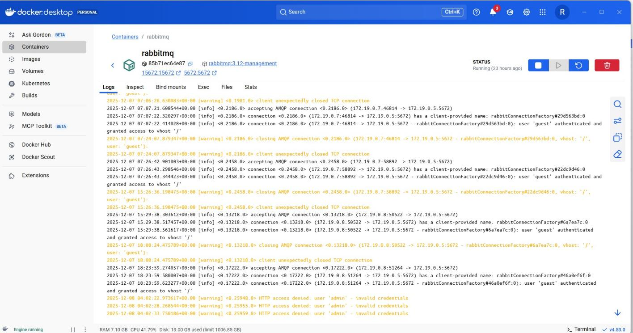

Mongodb logs

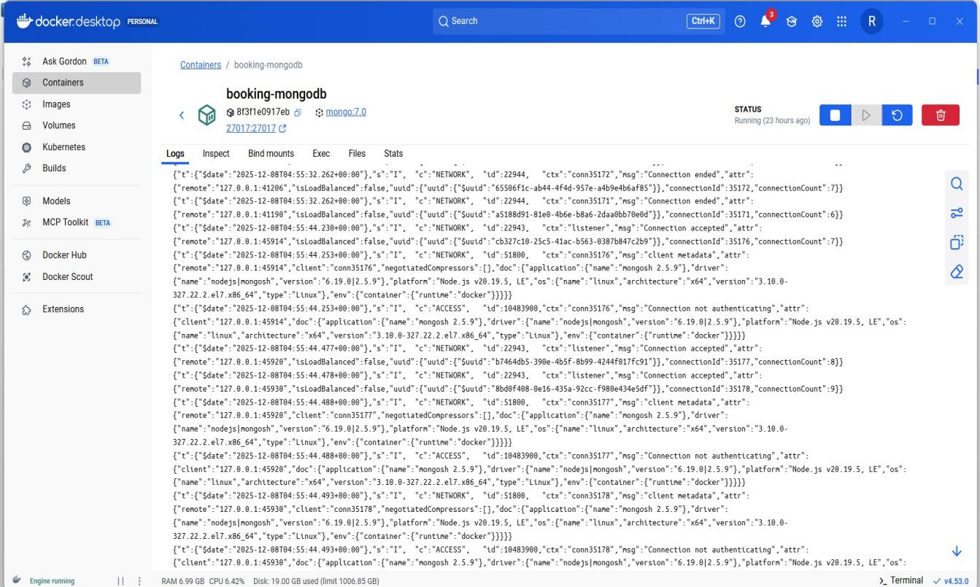

5.Mongodb screenshots

* Booking_db

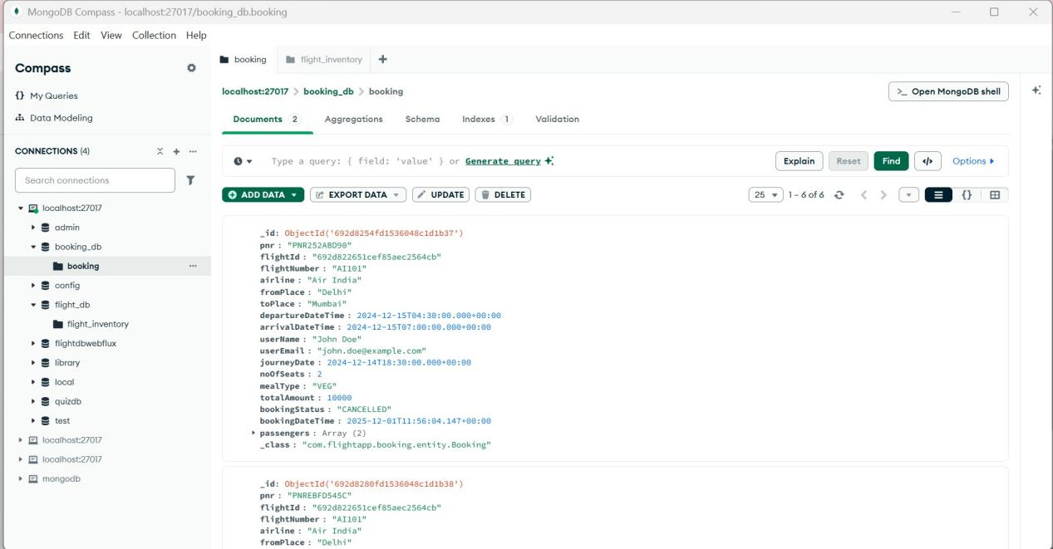

* **Flight_db**

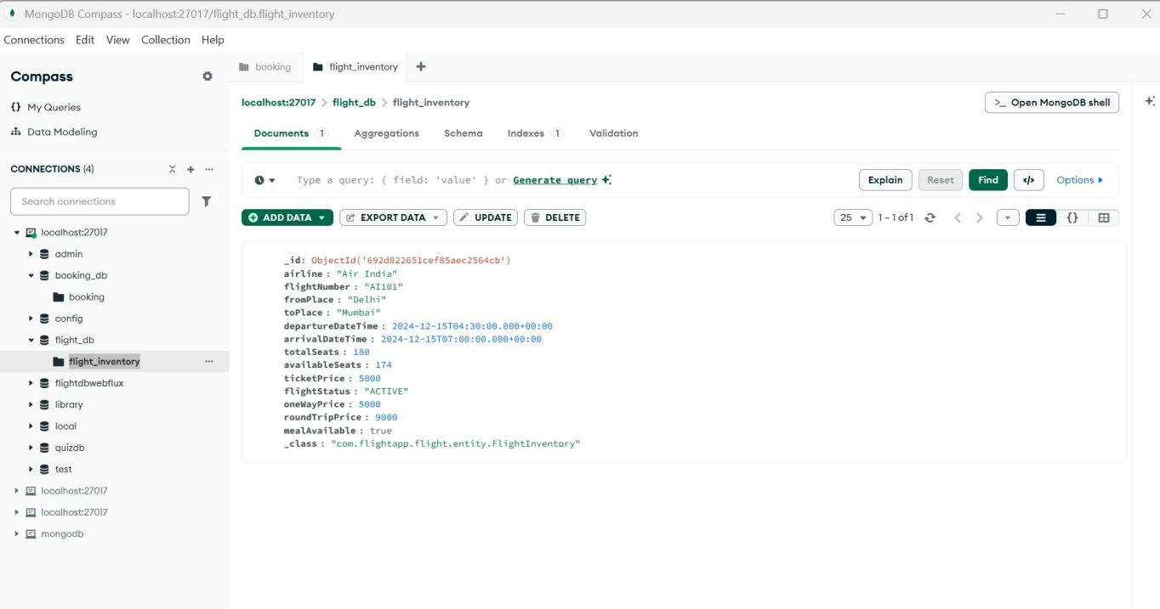

* Notification logs

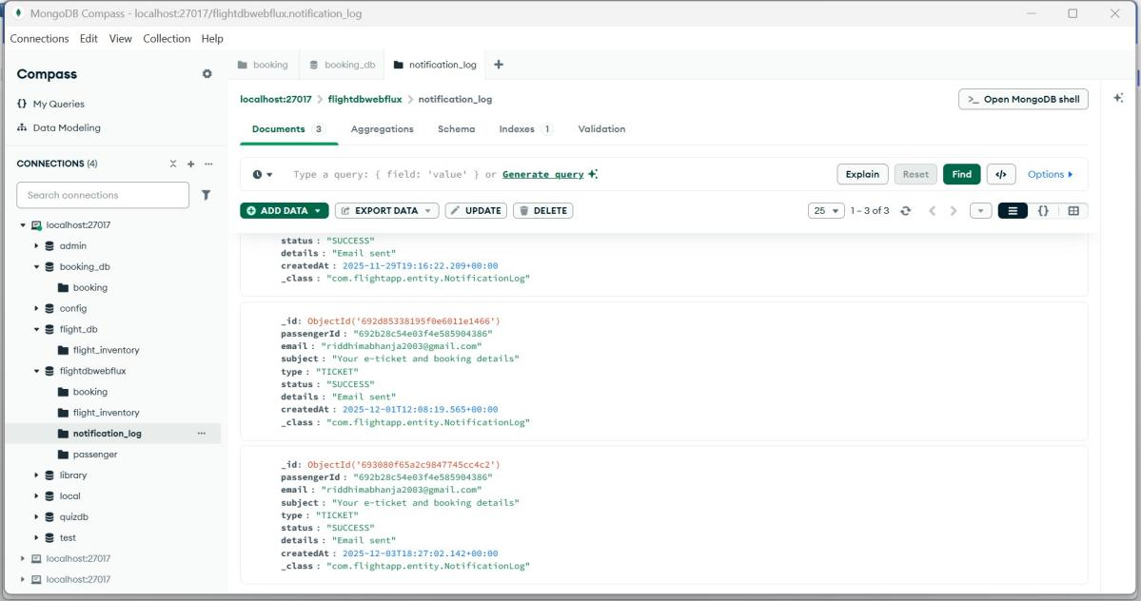

1. Email

* Welcome Email

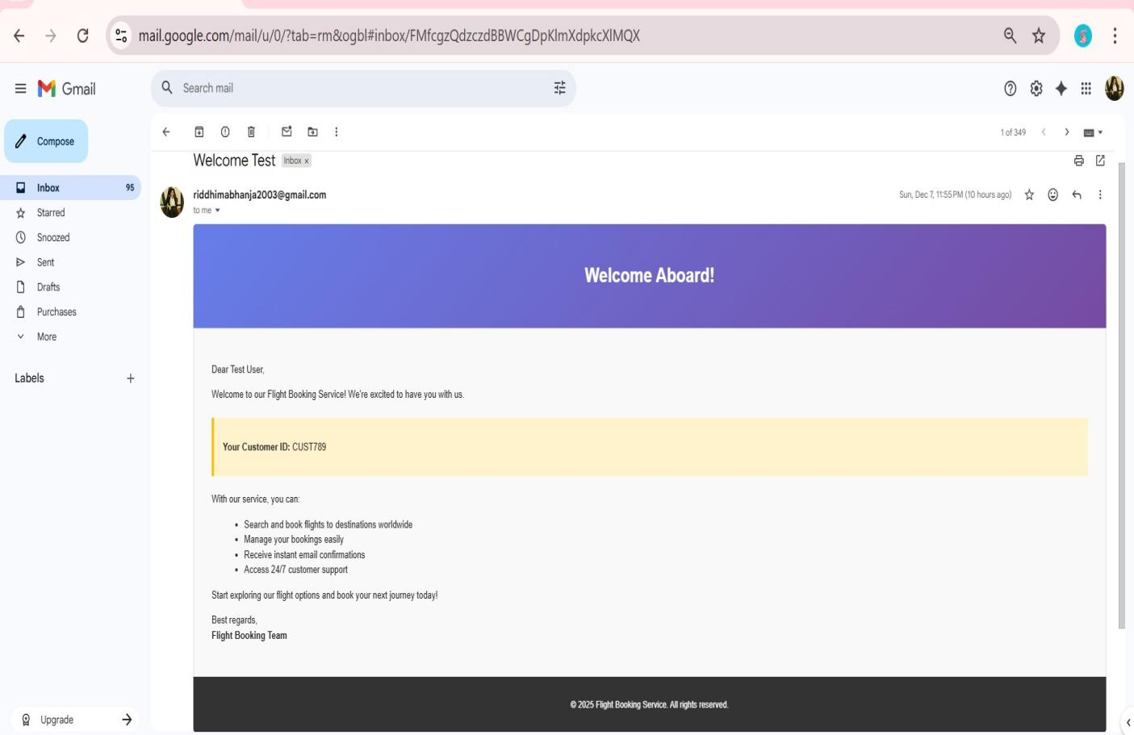

* Confirm Booking Email

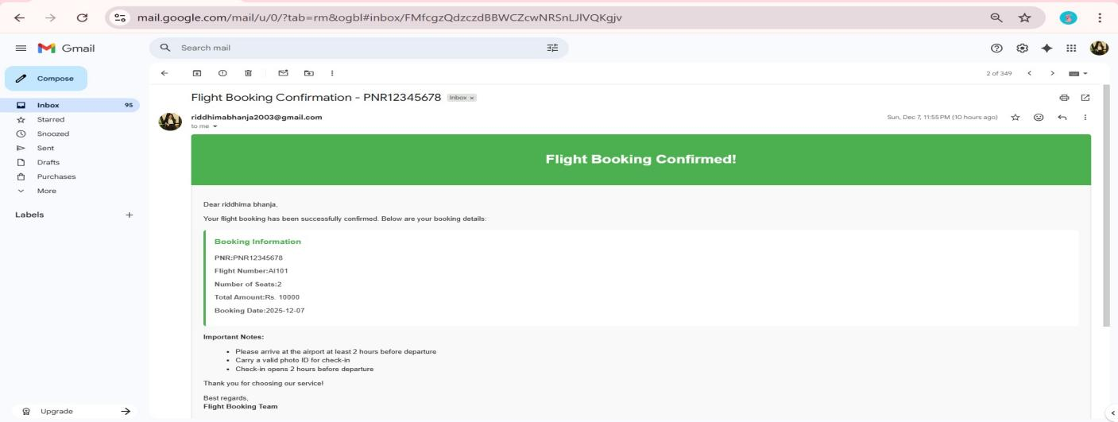

Flight cancel email

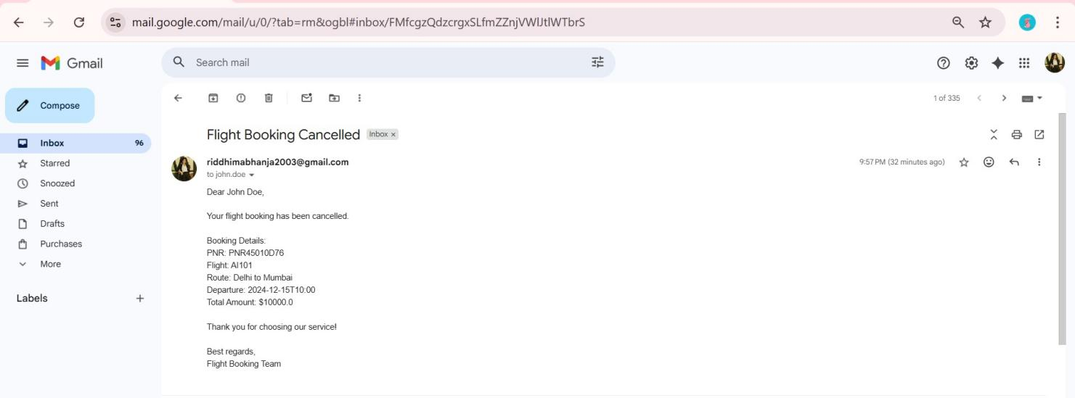

**RabbitMQ email-queue dashboard**

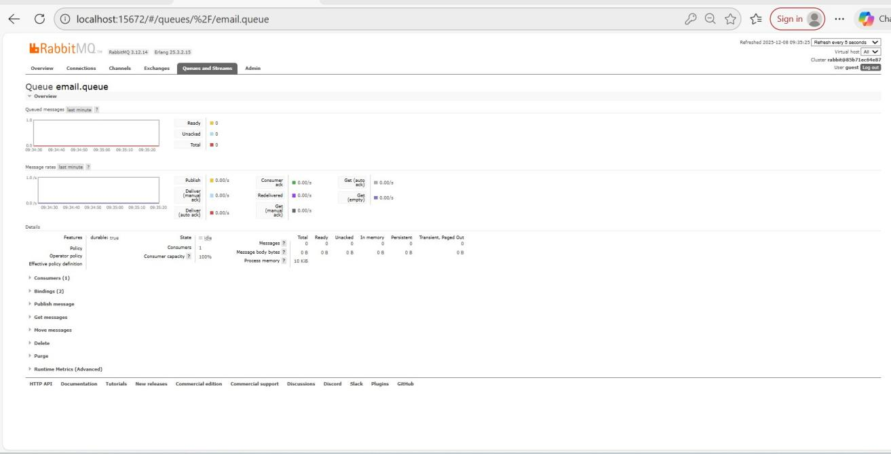

**RabbitMQ overview dashboard**

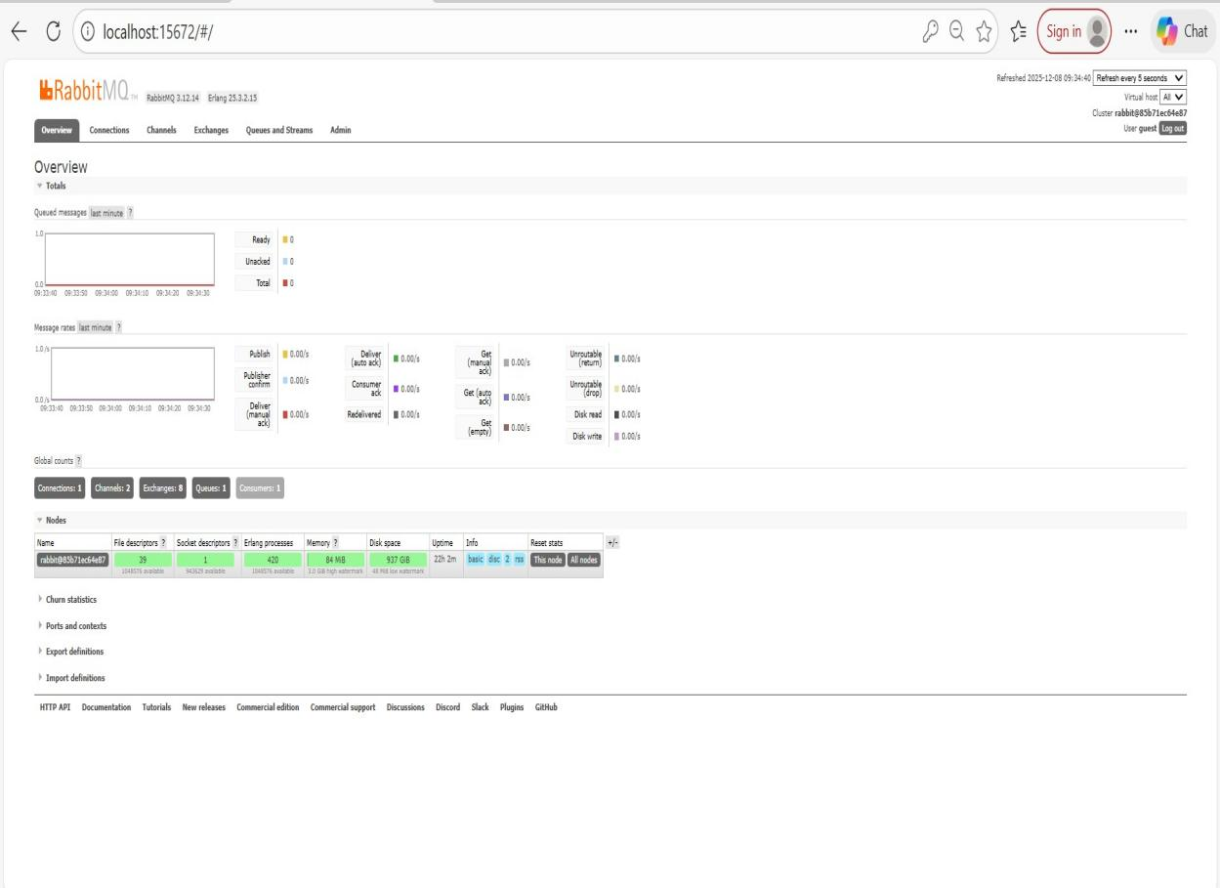

1. Postman screenshots

Obtain JWT TOKEN

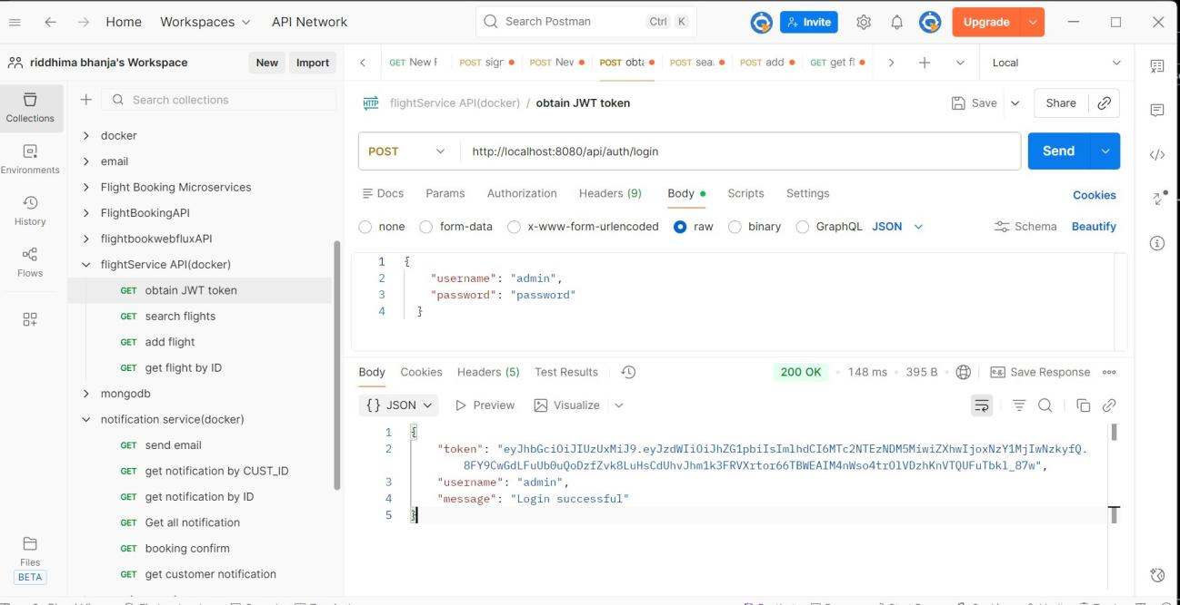

Unauthorized access

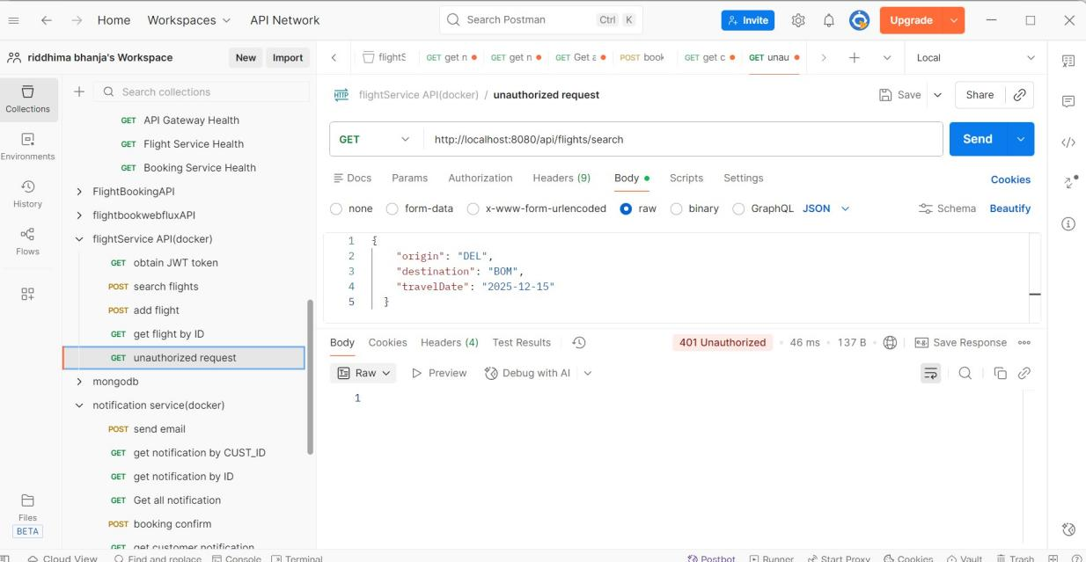

Same endpoint with auth bearer token

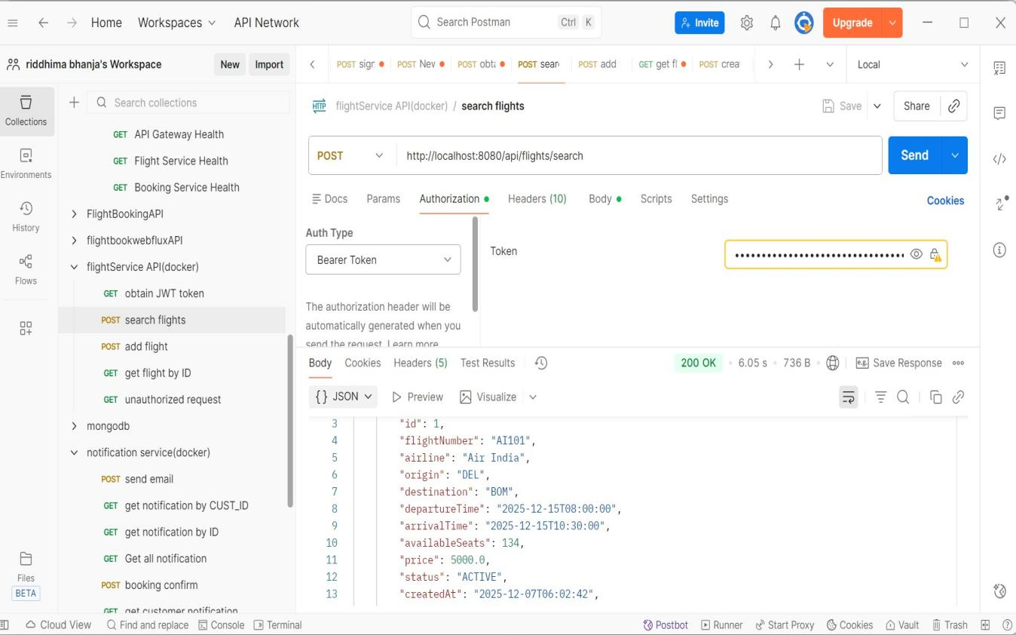

* **Circuit Breaker**

**Events:**

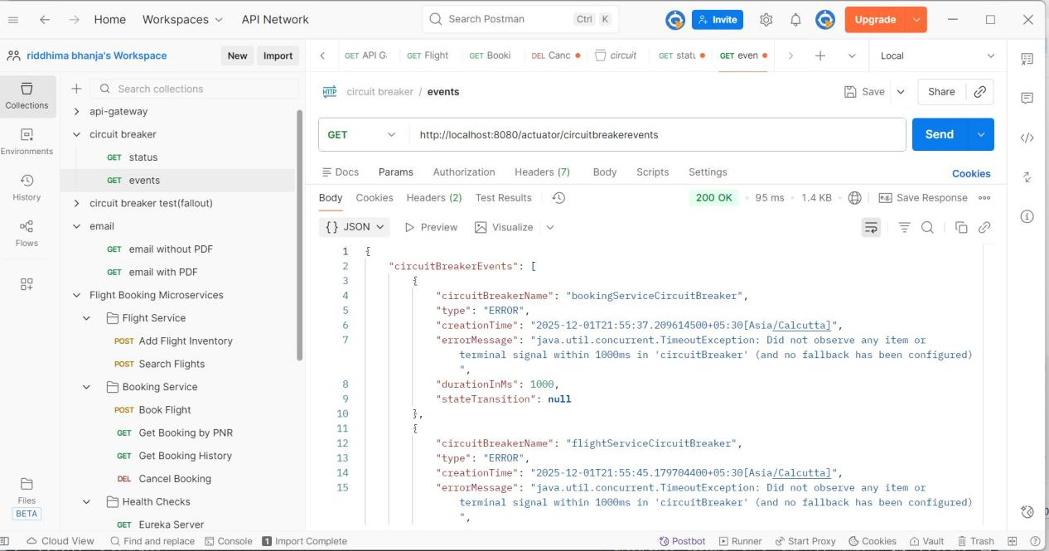

**Status:**

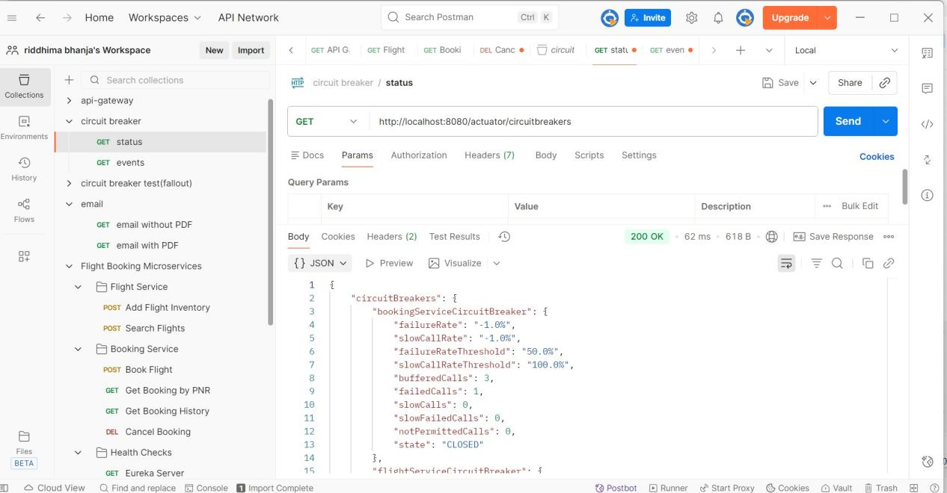

* **Health Check**

**API gateway health:**

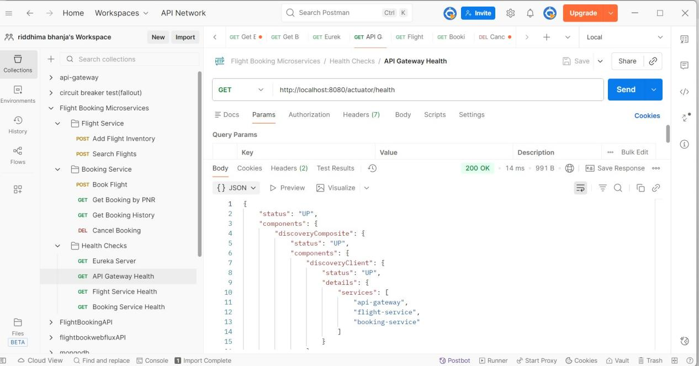

**Booking Service Health:**

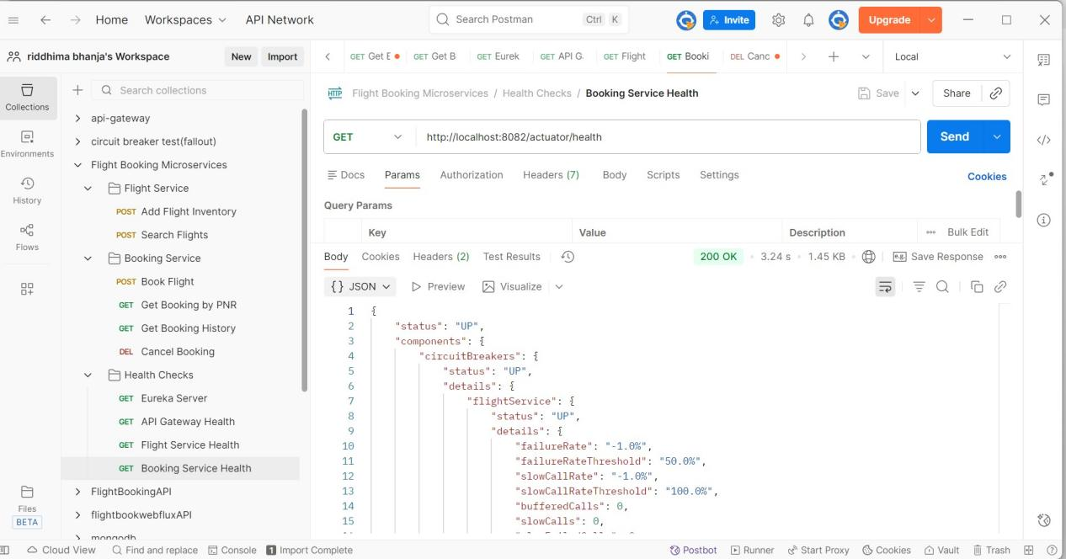

**Eureka server:**

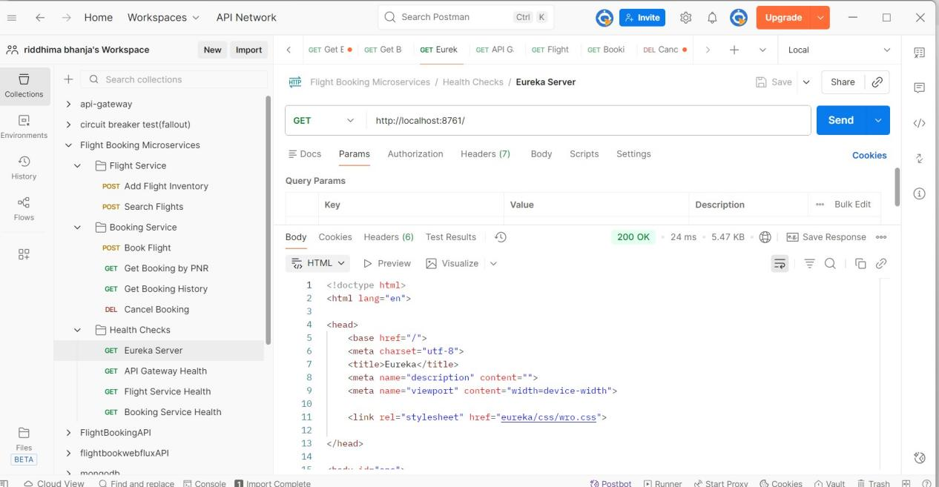

**Flight Service Health:**

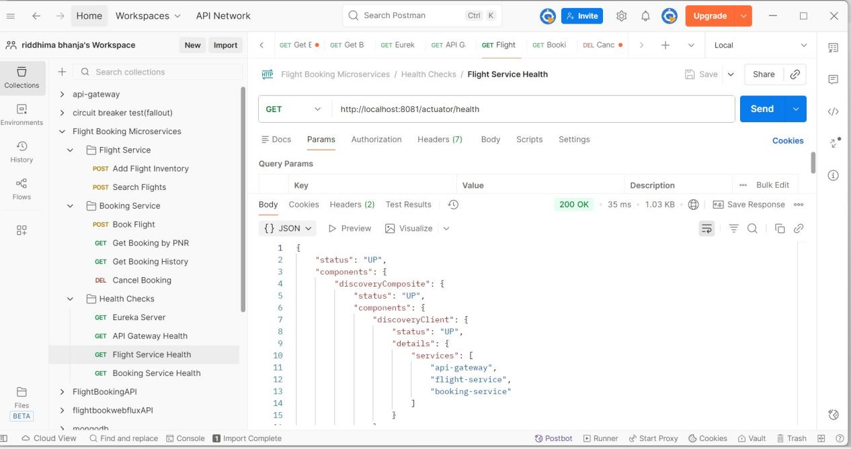

ADD FLIGHT

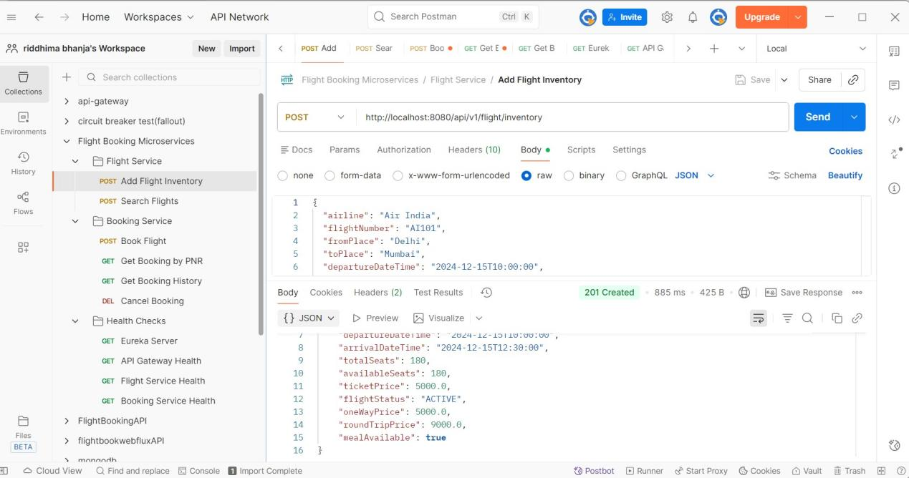

**BOOK FLIGHT**

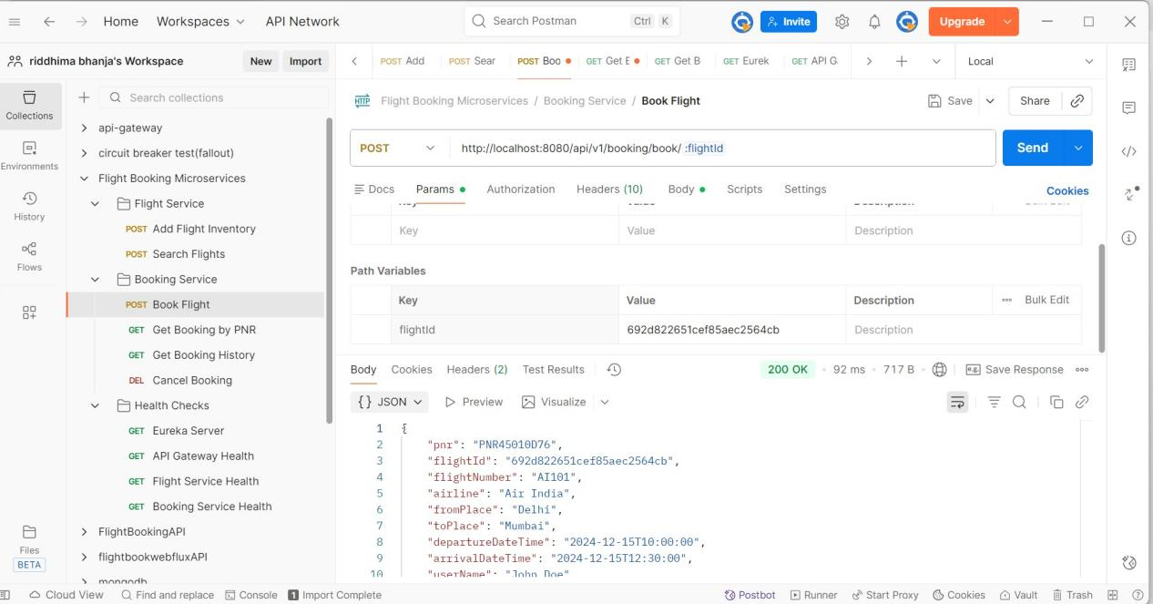

**SEARCH FLIGHTS**

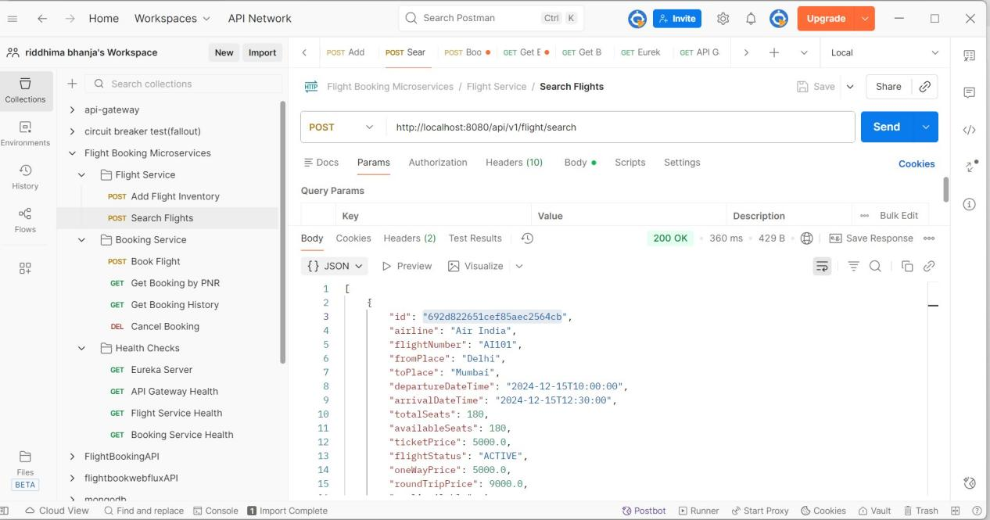

**CANCEL BOOKING**

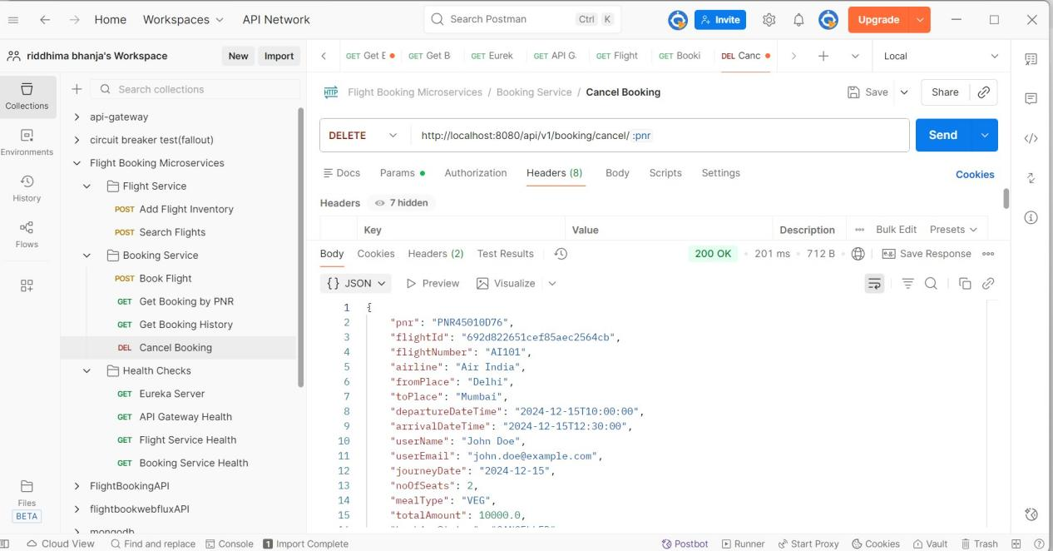

**GET BOOKING BY PNR**

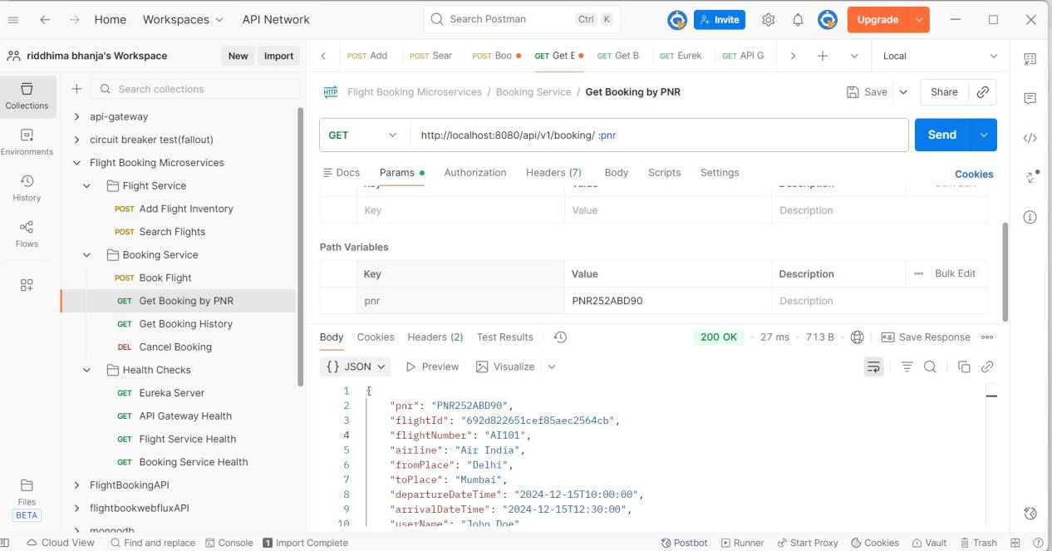

**GET BOOKING HISTORY**

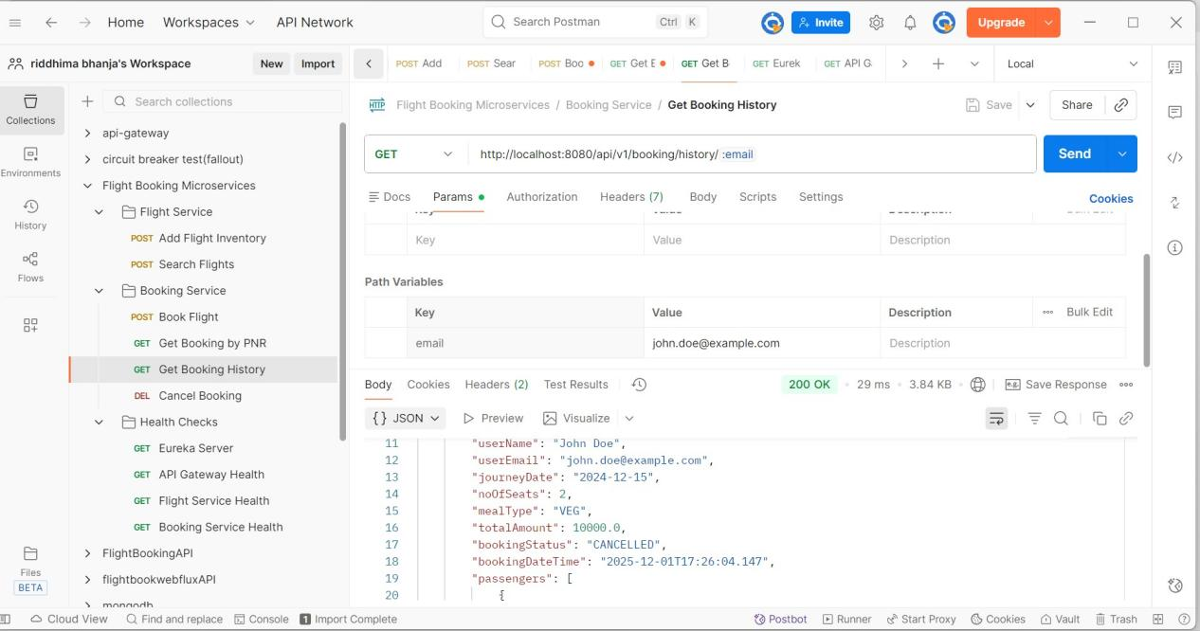

FALLBACK case

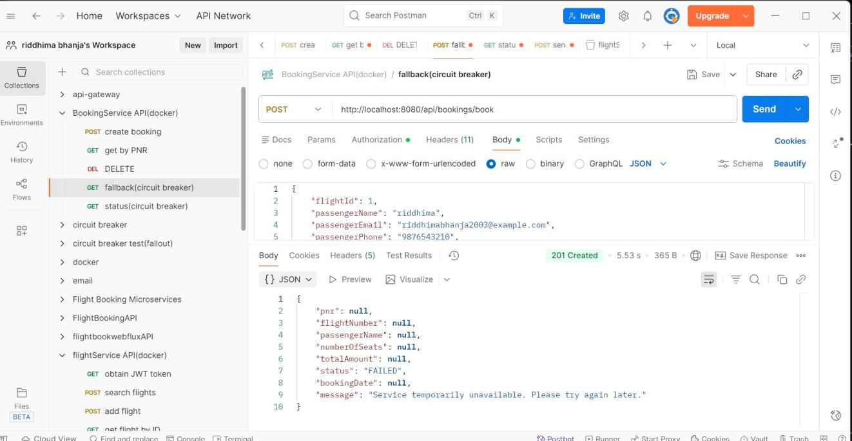

**SEND EMAIL**

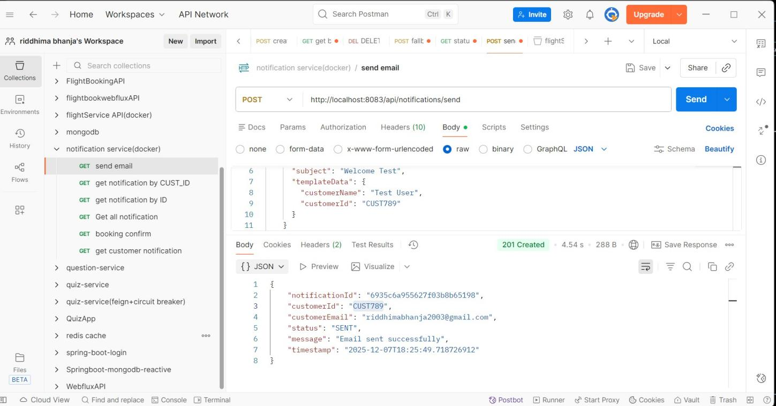

**GET BY ID**

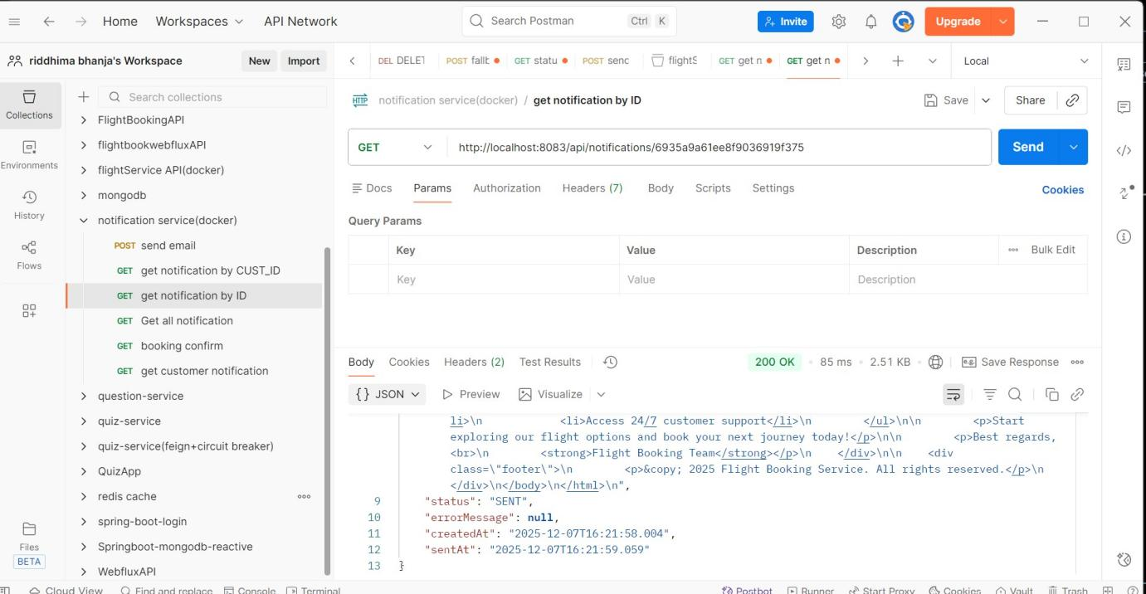

**BOOKING CONFIRMATION EMAIL**

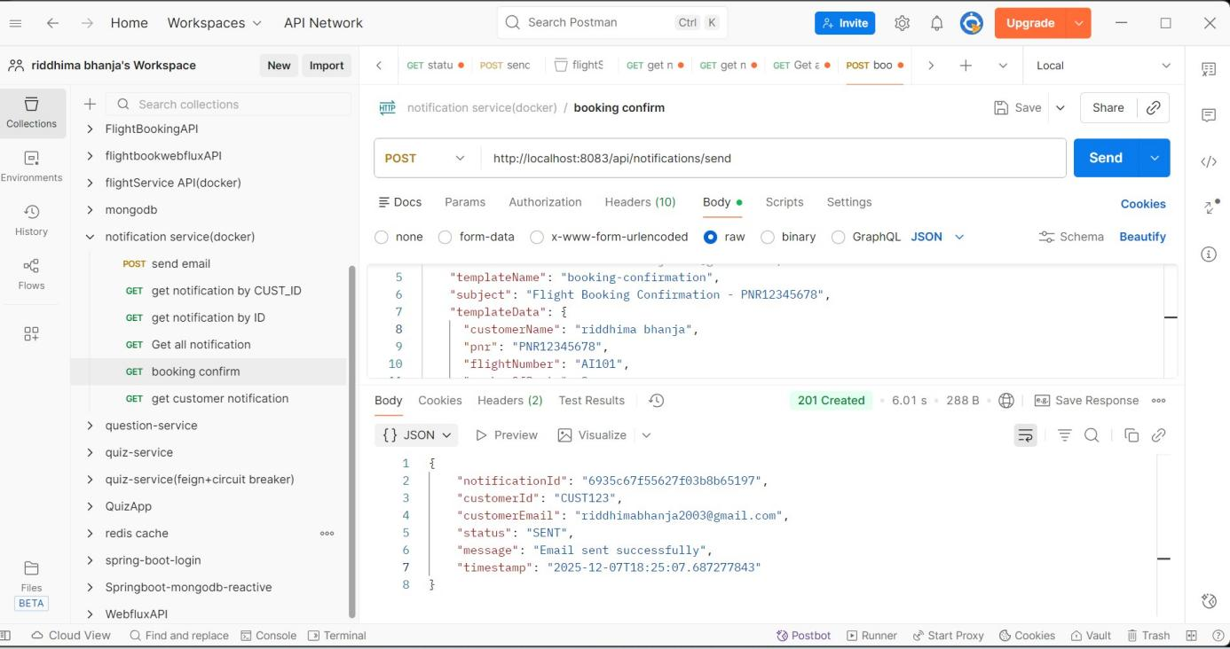

**GET ALL NOTIFICATION**

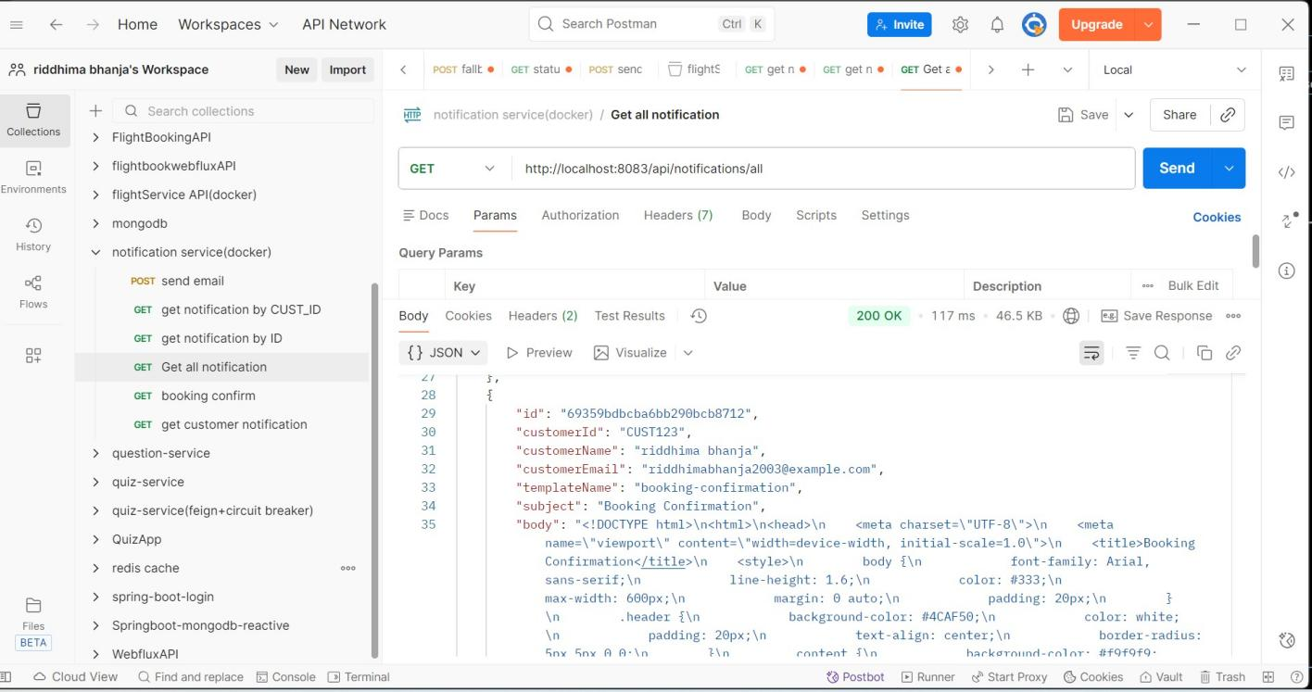

**GET CUSTOMER NOTIFICATION**

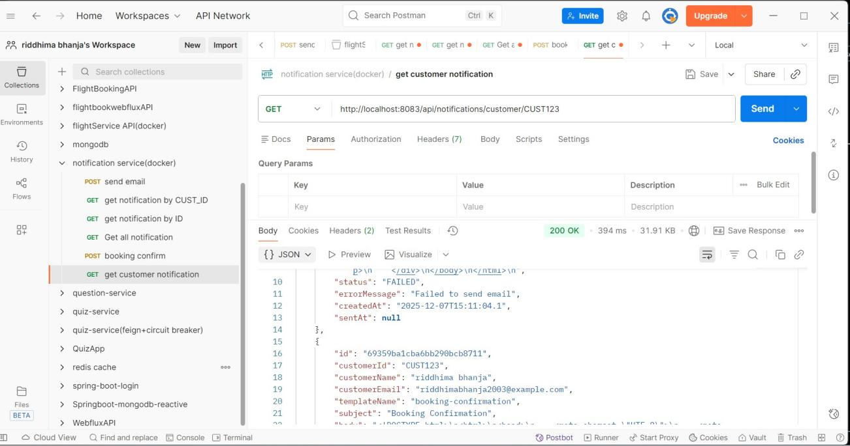

**CREATE BOOKING**

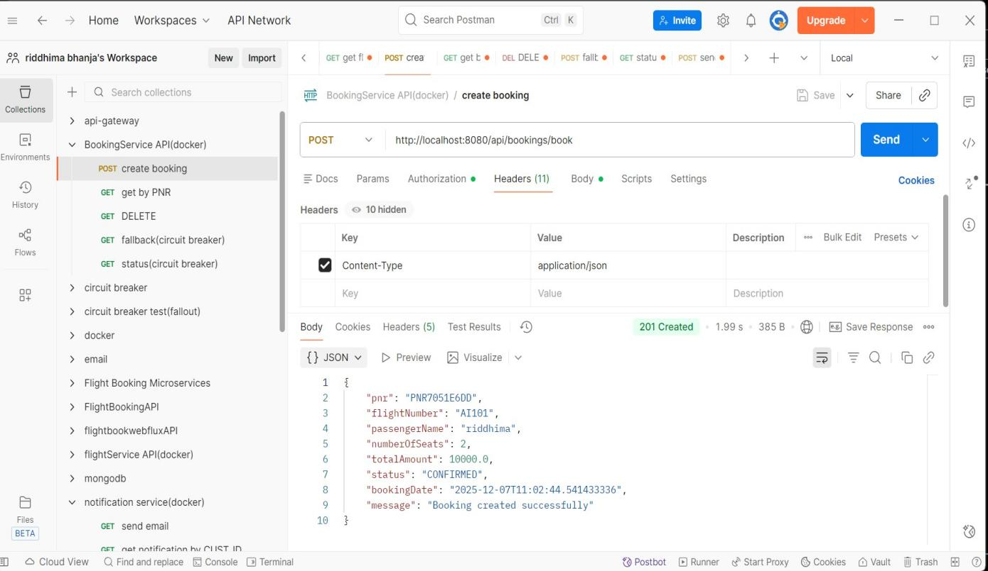

* Jmeter result tree

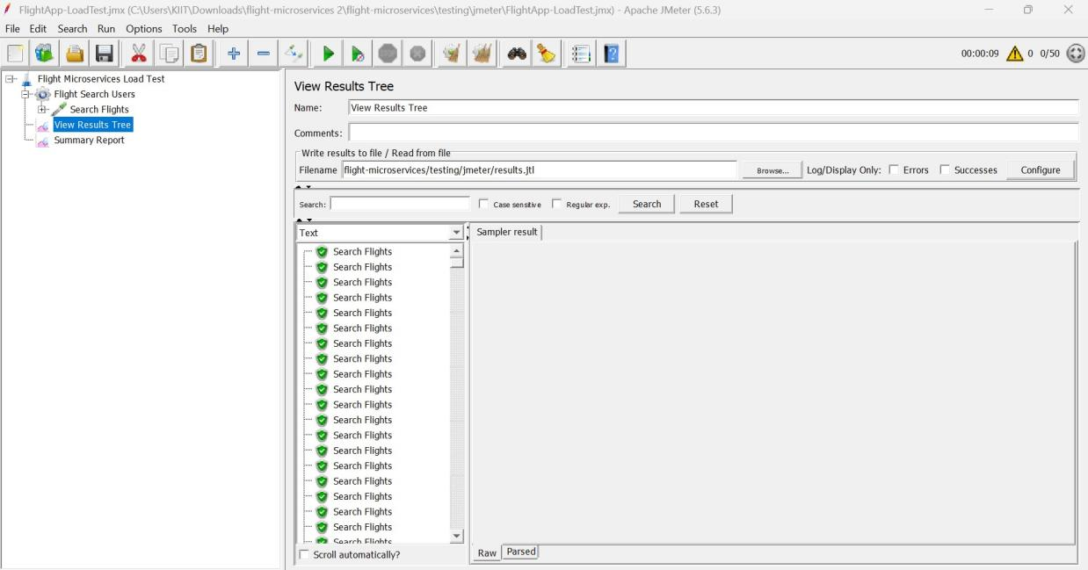

* **Jmeter Summary report**

**20 Requests**

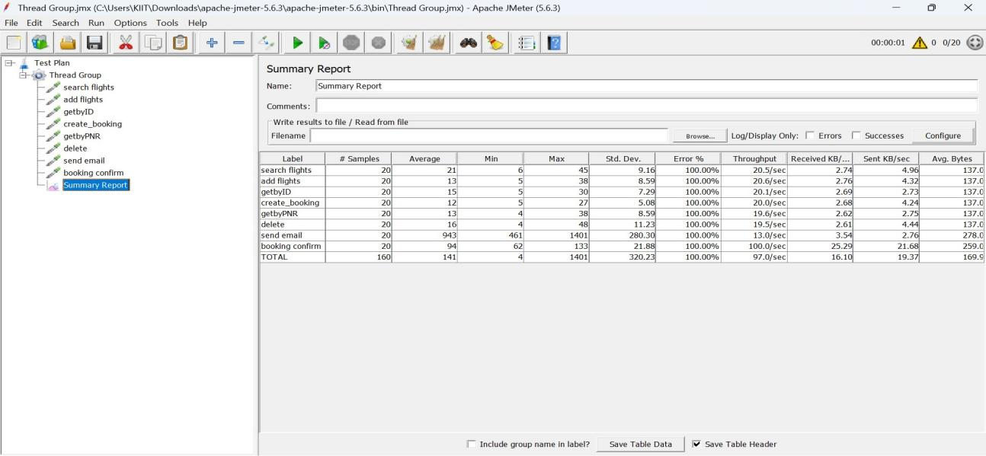

**50 Requests**

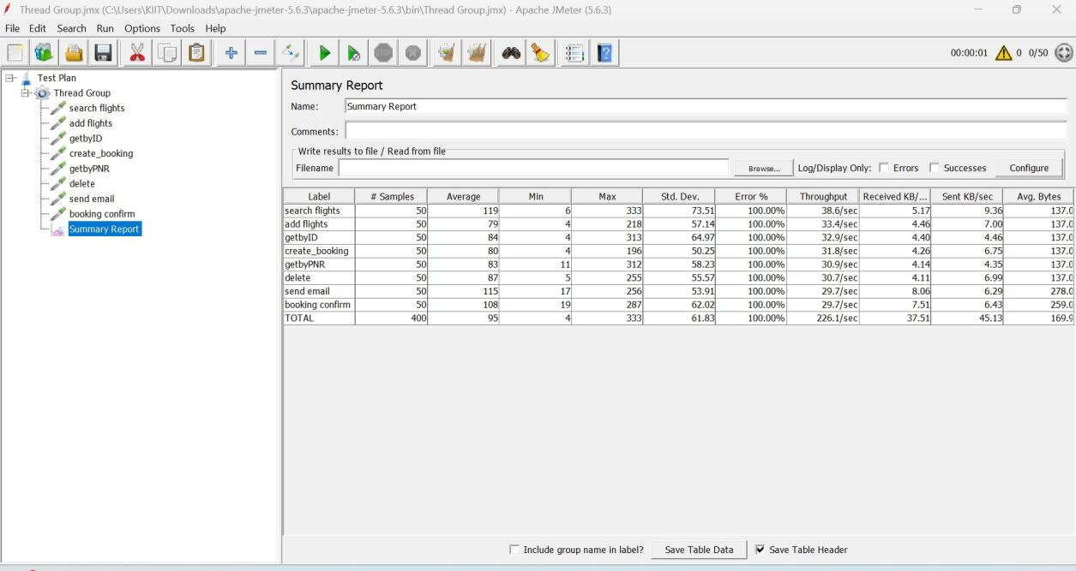

**100 Requests**

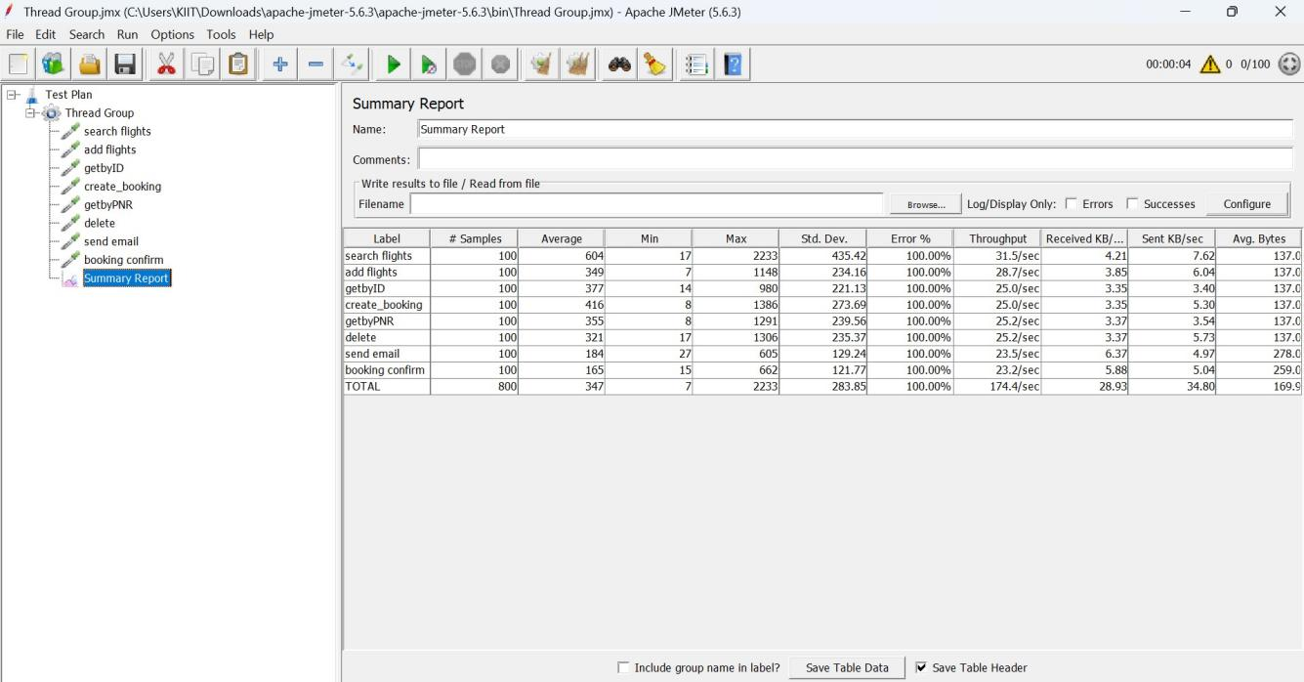

MySQL Workbench

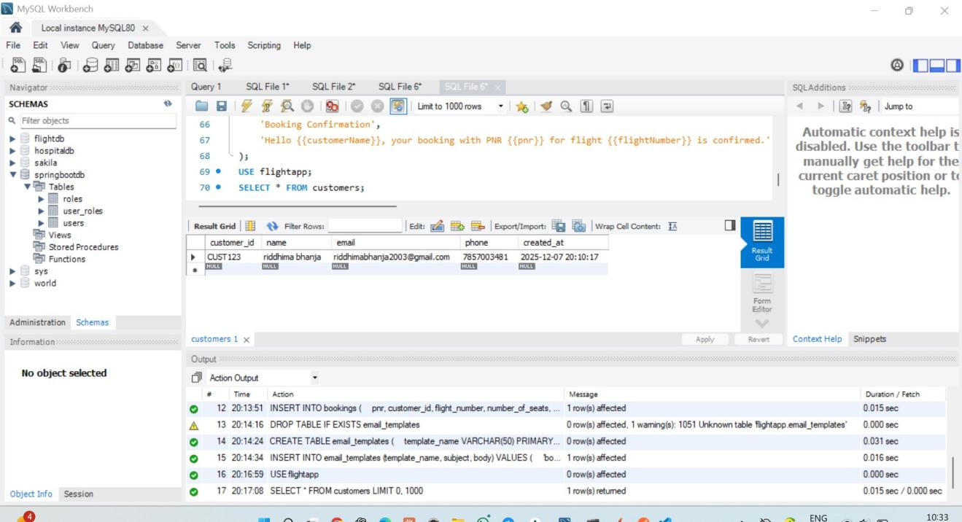

**EUREKA DASHBOARD**

